Snowflake Hands-On Practice Assignment
Dynamic Tables • Stored Procedures • Dashboards
Dynamic Tables: Automatically refreshed tables that keep derived data up to date without manual scheduling.
Stored Procedures: Reusable programs that run SQL logic to automate tasks and complex workflows.
Dashboards: Visual reports that display data insights using charts and metrics for quick decision-making.

Part 1: Dynamic Tables – Core Practice
- Create a source table orders_src with:
  - order_id
  - order_date
  - region
  - product
  - amount
create DATABASE
create DATABASE my_db;
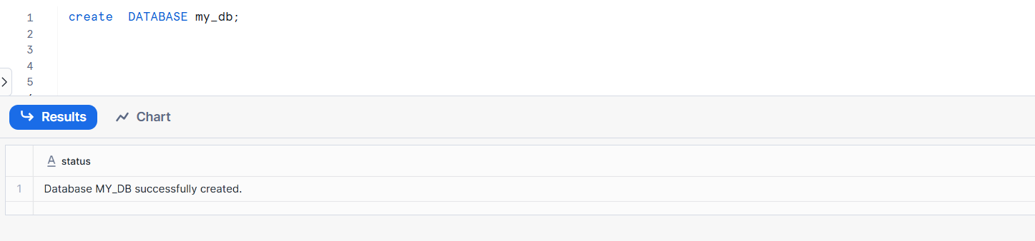
Create Schema
create SCHEMA my_schema;
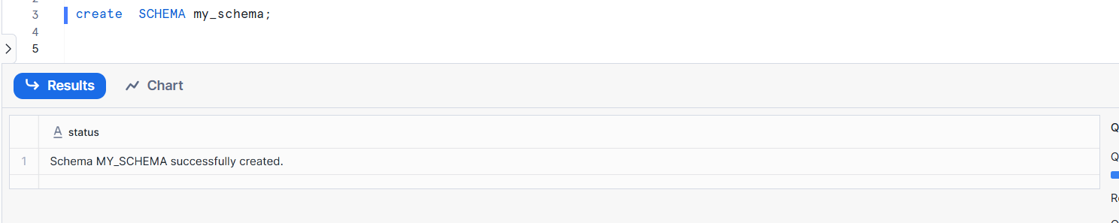
Create the source table orders_src
CREATE OR REPLACE TABLE orders_src (
order_id NUMBER,
order_date DATE,
region VARCHAR(50),
product VARCHAR(100),
amount NUMBER(10,2)
);

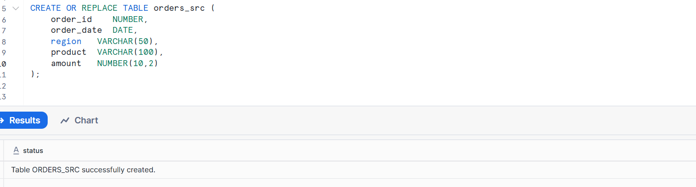
Verify the table structure

DESC TABLE orders_src;
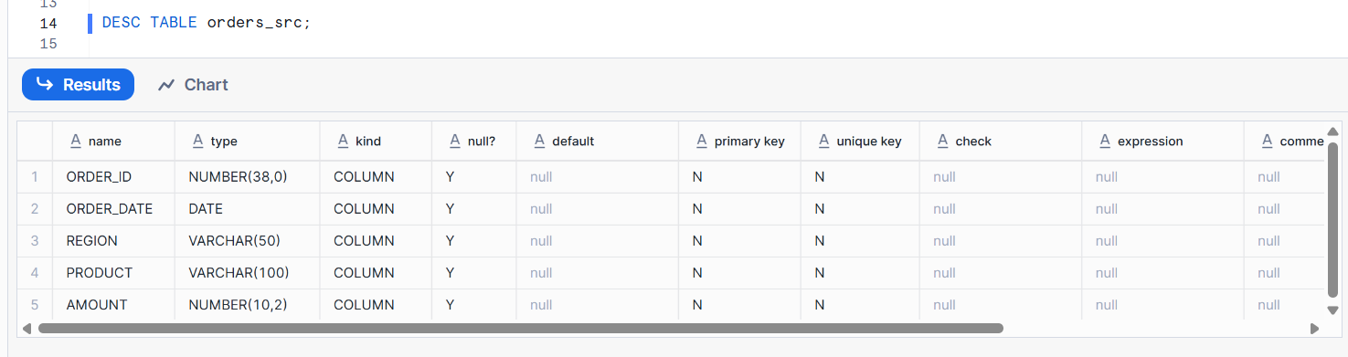
Insert sample data
INSERT INTO orders_src VALUES
(1, '2026-01-01', 'North', 'Laptop', 75000),
(2, '2026-01-02', 'South', 'Mobile', 30000),
(3, '2026-01-03', 'East', 'Tablet', 20000);
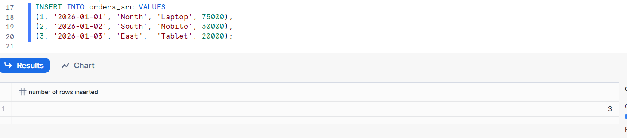
View the data
SELECT * FROM orders_src;
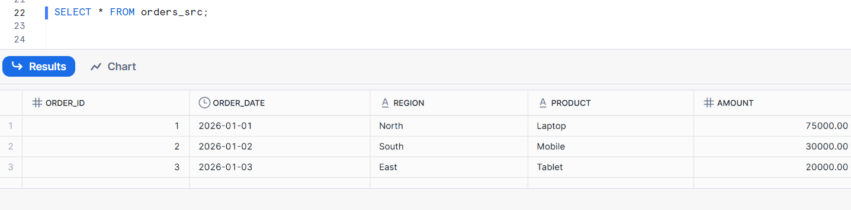
- Insert at least 8 records covering multiple regions and products.
INSERT INTO orders_src VALUES
(1, '2026-01-01', 'North', 'Laptop', 75000),
(2, '2026-01-02', 'South', 'Mobile', 30000),
(3, '2026-01-03', 'East', 'Tablet', 20000),
(4, '2026-01-04', 'West', 'Laptop', 72000),
(5, '2026-01-05', 'North', 'Headphones', 5000),
(6, '2026-01-06', 'South', 'Tablet', 22000),
(7, '2026-01-07', 'East', 'Mobile', 28000),
(8, '2026-01-08', 'West', 'Smart Watch', 15000);
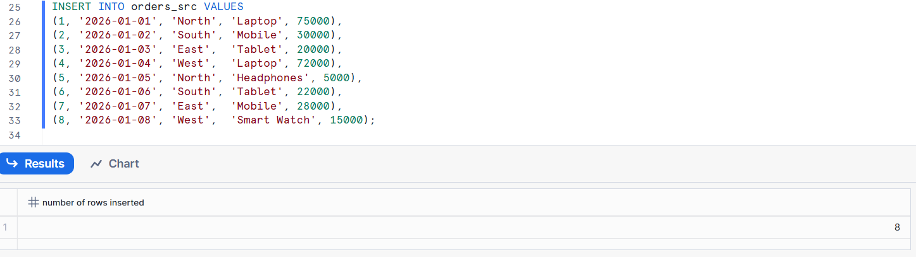
Verify the inserted data
SELECT * FROM orders_src;
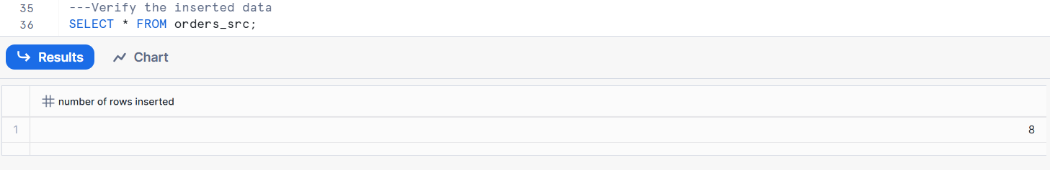
- Create a Dynamic Table orders_region_summary_dt that shows:
  - region
  - total_orders
  - total_sales
Set TARGET_LAG = 5 MINUTE.
Create the Dynamic Table
CREATE OR REPLACE DYNAMIC TABLE orders_region_summary_dt
TARGET_LAG = '5 MINUTE'
WAREHOUSE = COMPUTE_WH
AS
SELECT
region,
COUNT(order_id) AS total_orders,
SUM(amount) AS total_sales
FROM orders_src
GROUP BY region;
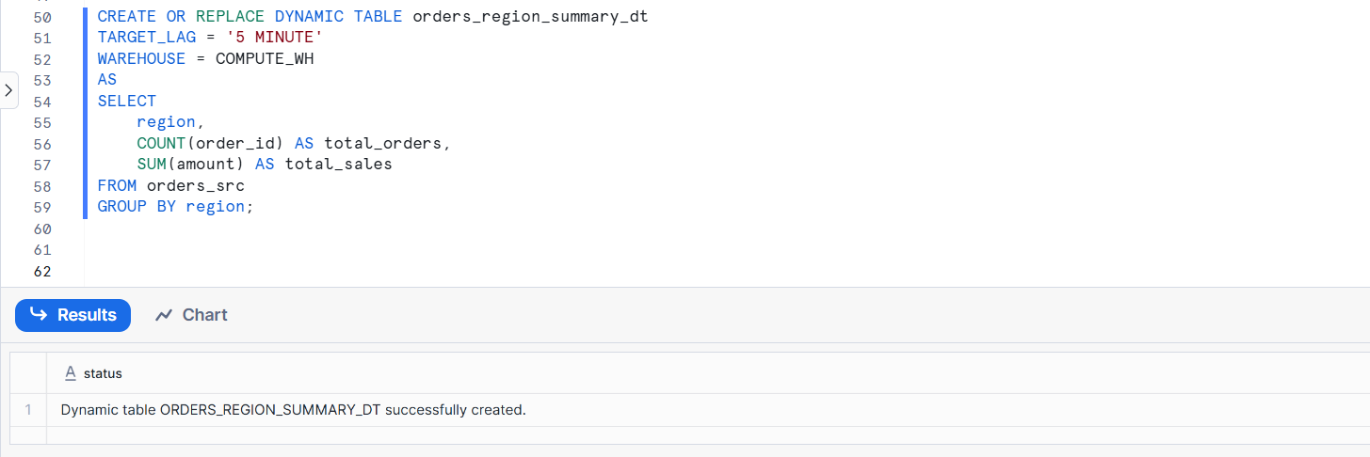
- Insert new records into orders_src and verify that the Dynamic Table updates automatically.
Insert new records into orders_src
INSERT INTO orders_src VALUES
(101, '2025-01-06', 'North', 'Keyboard', 3000),
(102, '2025-01-06', 'South', 'Mouse', 1500);
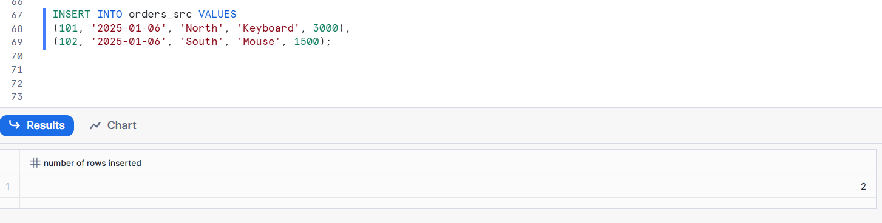
Check source table
SELECT * FROM orders_src;

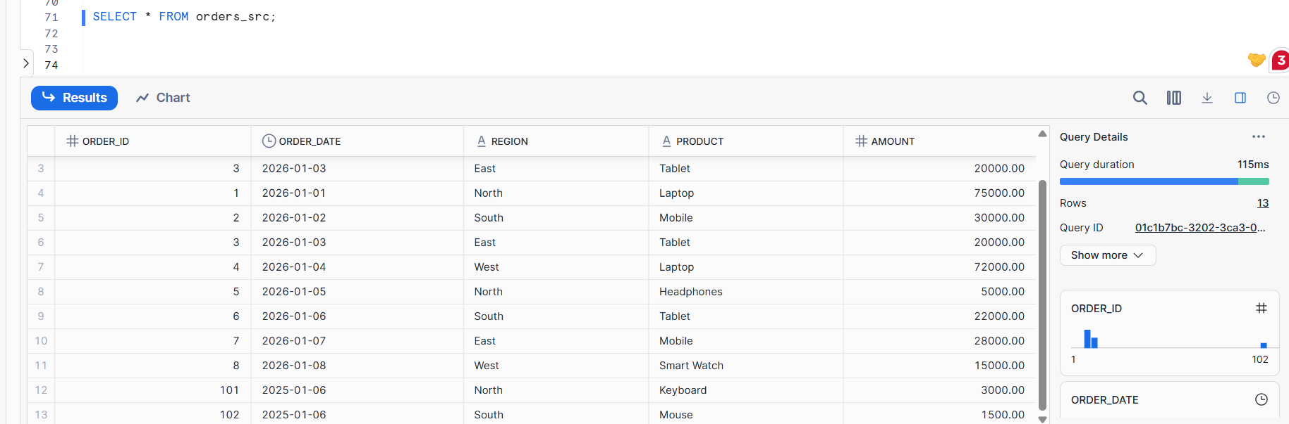
Verify Dynamic Table auto-update
SELECT * FROM orders_region_summary_dt;
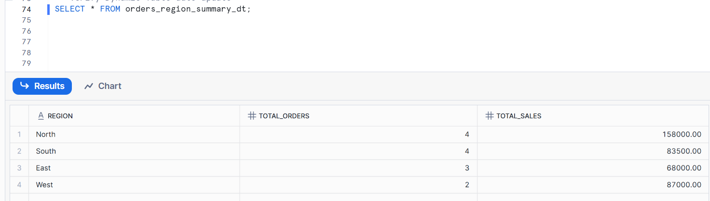
- Update the amount for an existing order and observe the Dynamic Table behavior.
Update an existing order amount
UPDATE orders_src
SET amount = 60000
WHERE order_id = 1;
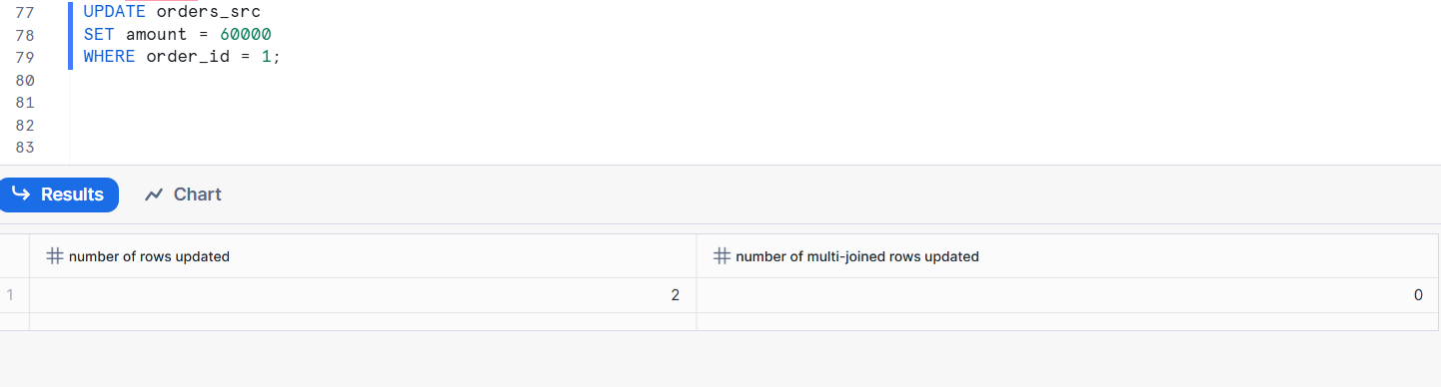
Verify source table update
SELECT * FROM orders_src
WHERE order_id = 1;
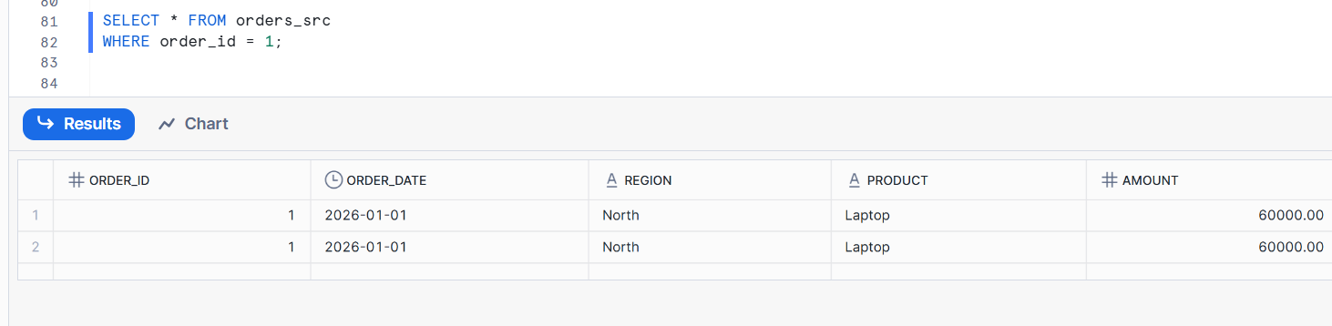
Check Dynamic Table
SELECT * FROM orders_region_summary_dt;
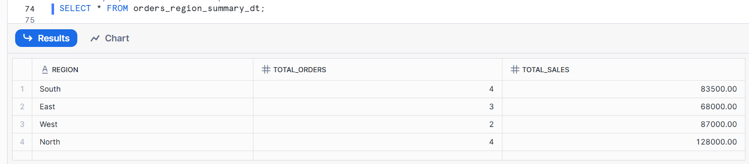
- Delete one record from orders_src.
Re-query the Dynamic Table and note the result.
Delete one record from orders_src
DELETE FROM orders_src
WHERE order_id = 2;
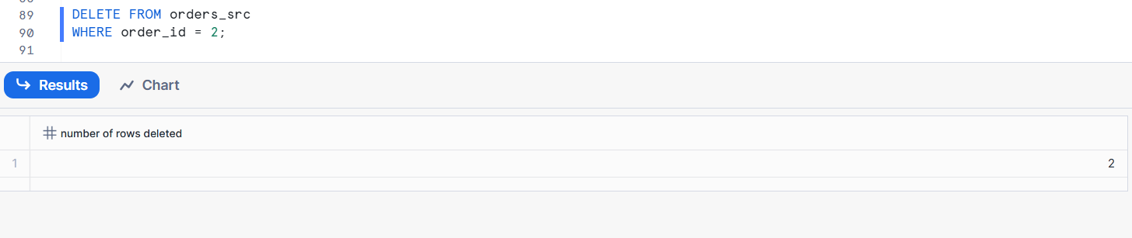
Verify delete
SELECT * FROM orders_src
WHERE order_id = 2;
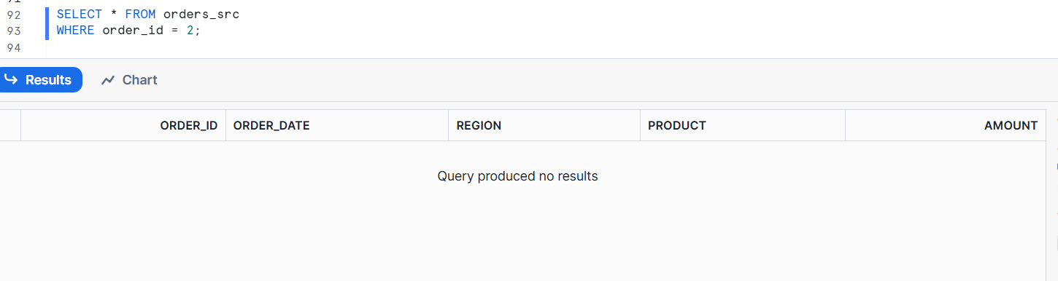
Re-query the Dynamic Table
SELECT * FROM orders_region_summary_dt;
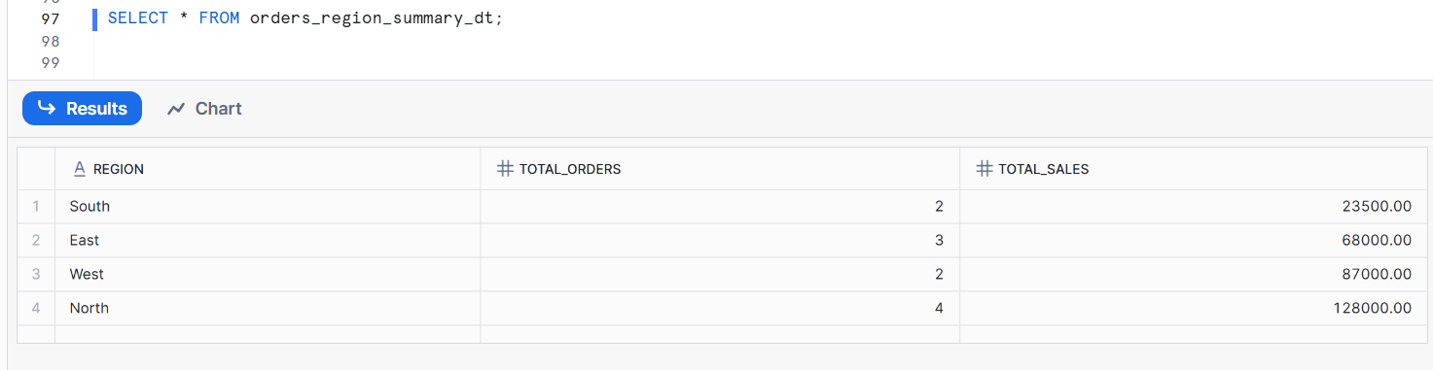

- Dynamic Tables automatically reflect DELETE changes from source tables.
- Suspend the warehouse used by the Dynamic Table.
Query the Dynamic Table and observe what happens.
Suspend the warehouse
ALTER WAREHOUSE COMPUTE_WH SUSPEND;
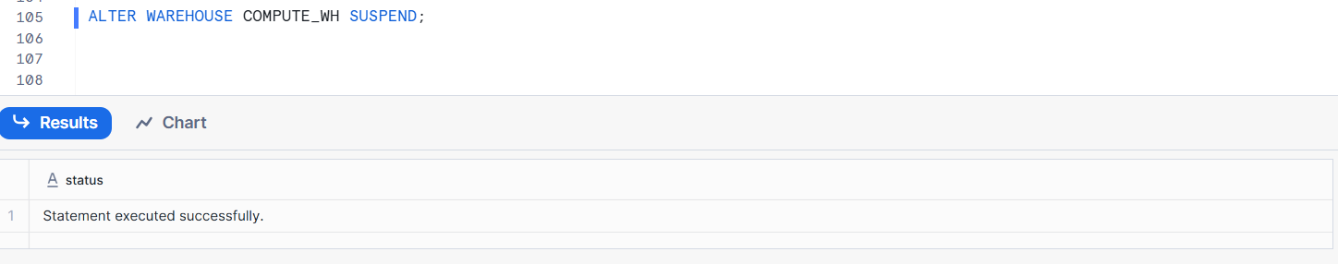
Query the Dynamic Table
SELECT * FROM orders_region_summary_dt;
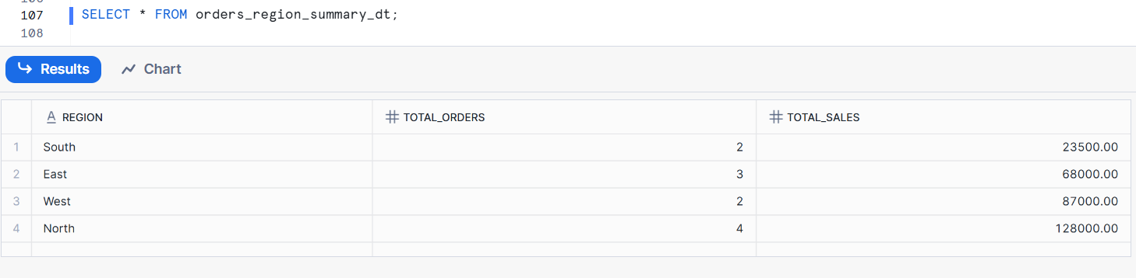
I suspended the warehouse, but the query still works.
Resume the warehouse (to continue refresh)
ALTER WAREHOUSE COMPUTE_WH RESUME;
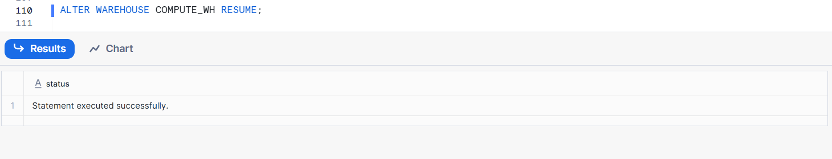

Part 2: Dynamic Table Dependency Chain
- Create a Dynamic Table orders_clean_dt that:
  - Filters out records where amount <= 0.
Create the Dynamic Table orders_clean_dt
CREATE OR REPLACE DYNAMIC TABLE orders_clean_dt
TARGET_LAG = '5 MINUTE'
WAREHOUSE = COMPUTE_WH
AS
SELECT
order_id,
order_date,
region,
product,
amount
FROM orders_src
WHERE amount > 0;
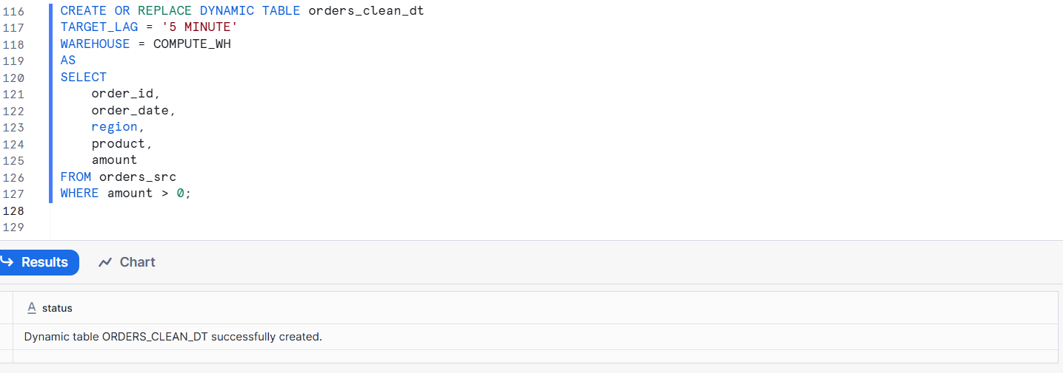
Verify the Dynamic Table
SELECT * FROM orders_clean_dt;
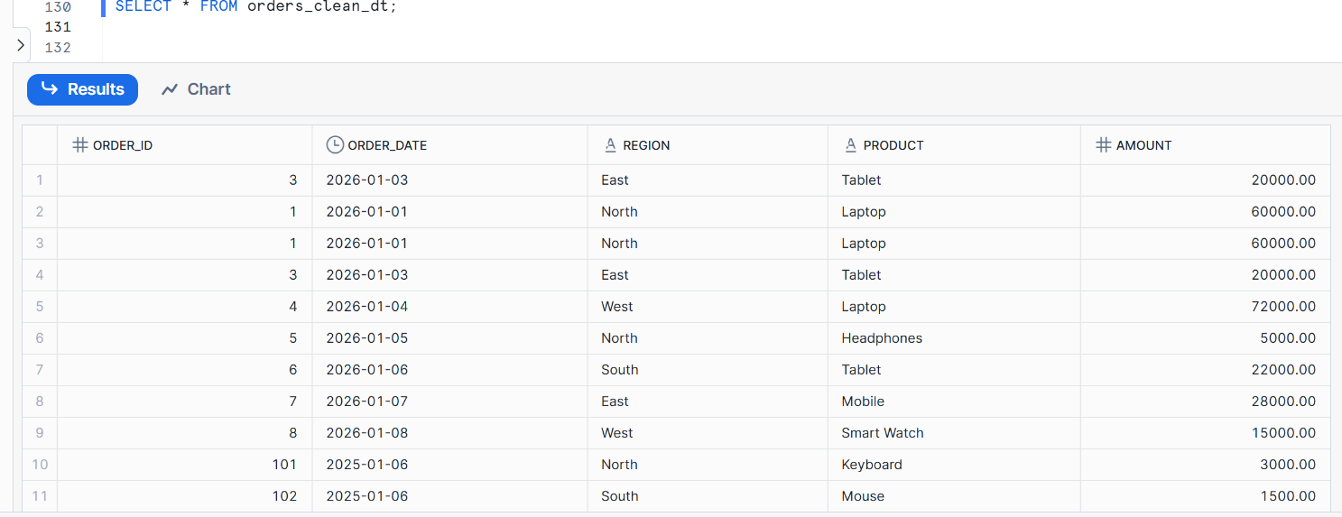
- Create another Dynamic Table orders_product_kpi_dt that:
-- Create the Dynamic Table
CREATE OR REPLACE DYNAMIC TABLE orders_product_kpi_dt
TARGET_LAG = '5 MINUTE'
WAREHOUSE = COMPUTE_WH
AS
SELECT
product,
COUNT(order_id) AS total_orders,
SUM(amount) AS total_sales
FROM orders_clean_dt
GROUP BY product;
--Check result
SELECT * FROM orders_product_kpi_dt;

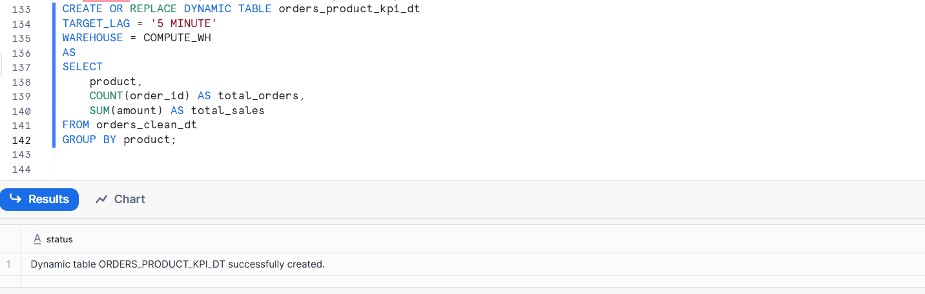
Check result
SELECT * FROM orders_product_kpi_dt;
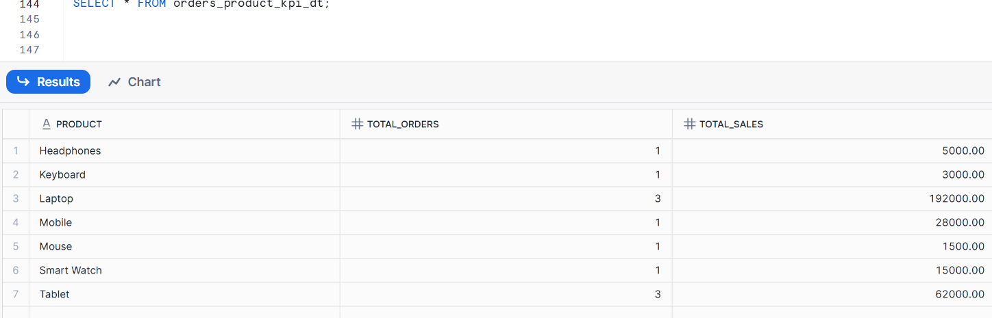
  - Depends on orders_clean_dt
orders_product_kpi_dt is built on top of orders_clean_dt, not directly on the source table.
  - Shows total_sales and total_orders by product.
What the Dynamic Table does
SELECT
product,
COUNT(order_id) AS total_orders,
SUM(amount) AS total_sales
FROM orders_clean_dt
GROUP BY product;
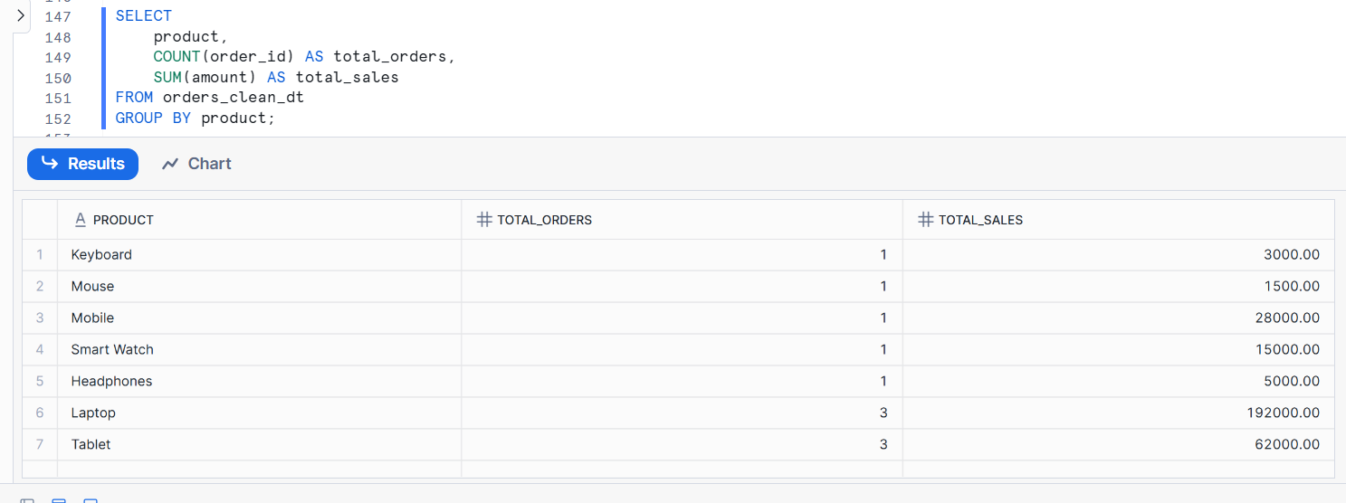
- Insert invalid and valid records into orders_src.
Verify how both Dynamic Tables behave.
Insert valid and invalid records into orders_src
INSERT INTO orders_src VALUES
(201, '2025-01-10', 'North', 'Laptop', 45000), --validate
(202, '2025-01-10', 'South', 'Mobile', 0), ---Invalidate
(203, '2025-01-10', 'East', 'Tablet', -5000); ---invalidate
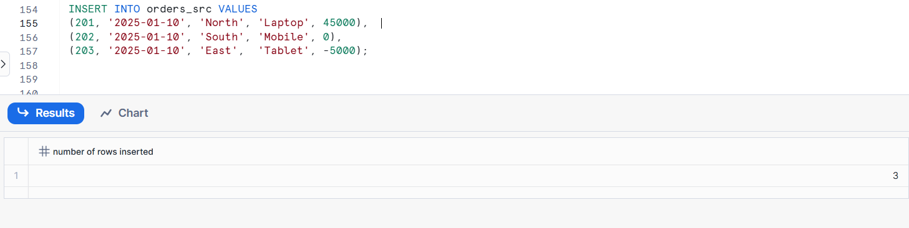
Check source table
SELECT order_id, product, amount FROM orders_src;
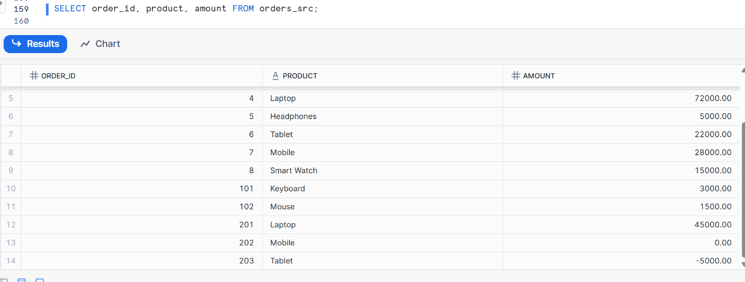
Verify orders_clean_dt
SELECT order_id, product, amount
FROM orders_clean_dt;
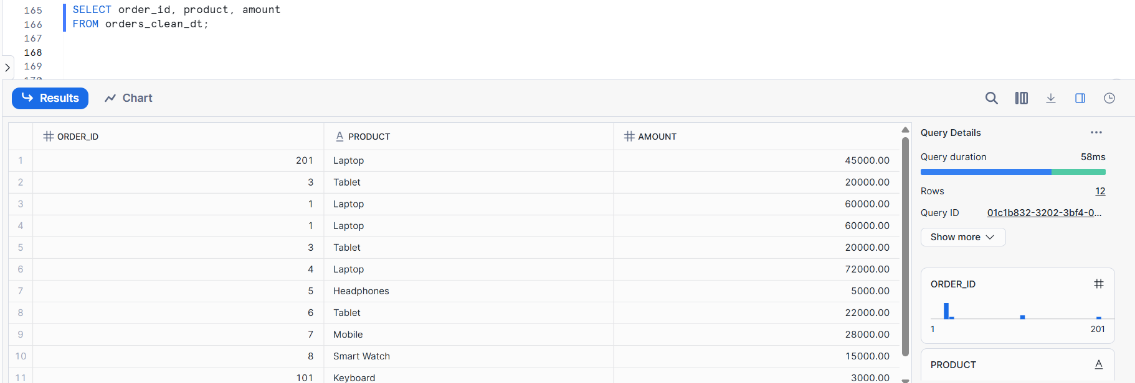
Verify orders_product_kpi_dt
SELECT * FROM orders_product_kpi_dt;
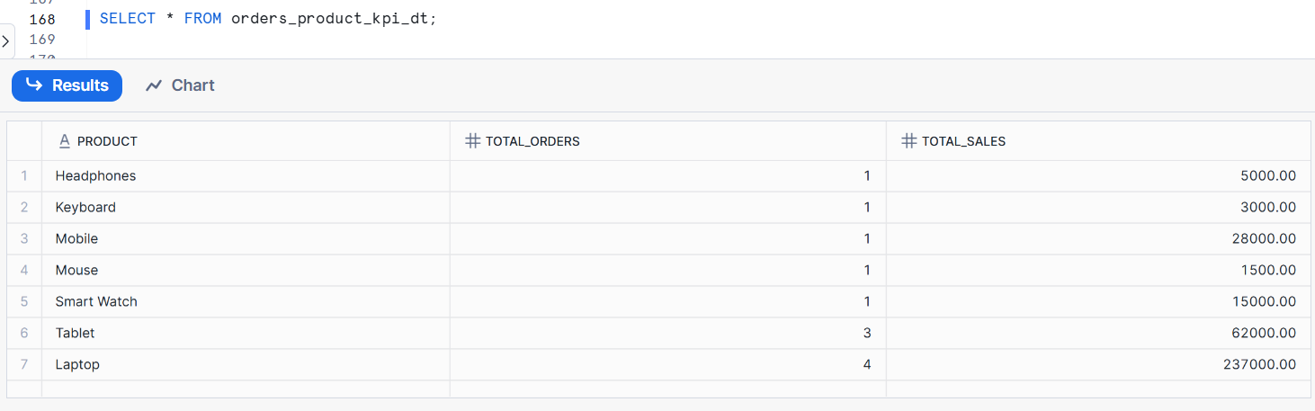
- Change data in the base table and confirm refresh order without manual scheduling.
Change data in the base table (orders_src)
INSERT INTO orders_src VALUES
(301, '2025-01-12', 'West', 'Laptop', 65000);
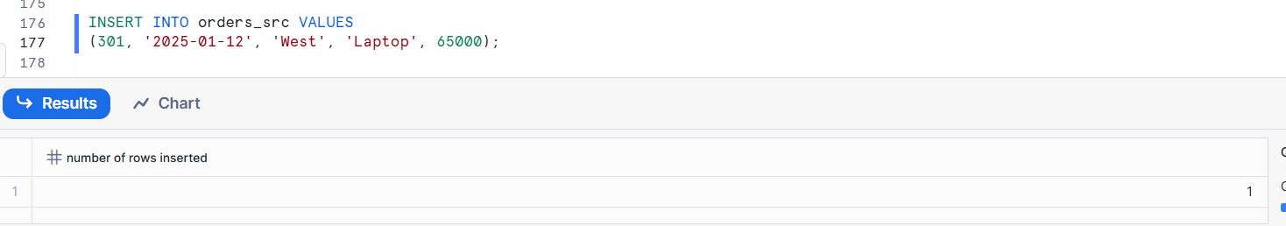
Check orders_clean_dt
SELECT * FROM orders_clean_dt
WHERE order_id = 301;
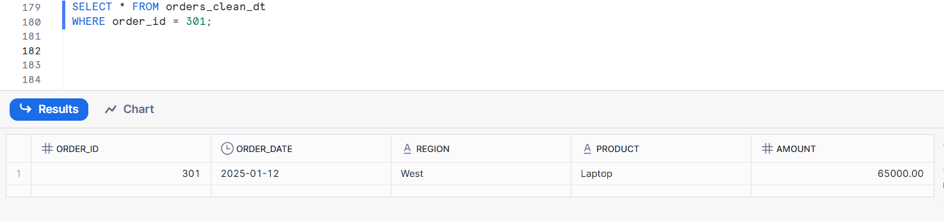
Check orders_product_kpi_dt
SELECT * FROM orders_product_kpi_dt
WHERE product = 'Laptop';
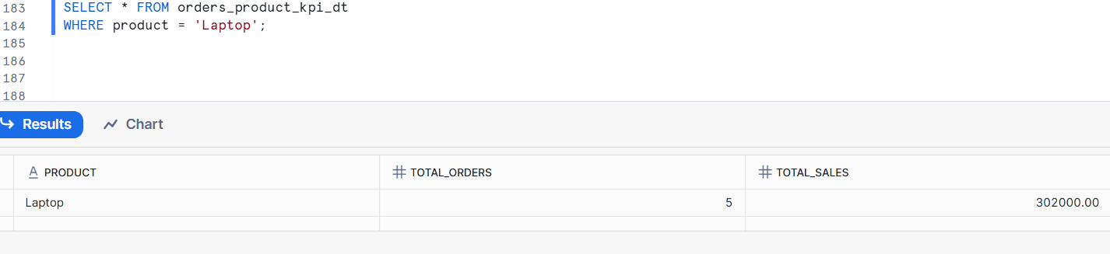
Laptop total_orders and total_sales updated

Part 3: SCD Type 1Using Dynamic Tables
- Create a source table customer_src with:
- customer_id
- customer_name
- city
- updated_at
reate a source table customer_src with:
CREATE OR REPLACE TABLE customer_src (
customer_id NUMBER,
customer_name STRING,
city STRING,
updated_at TIMESTAMP
);
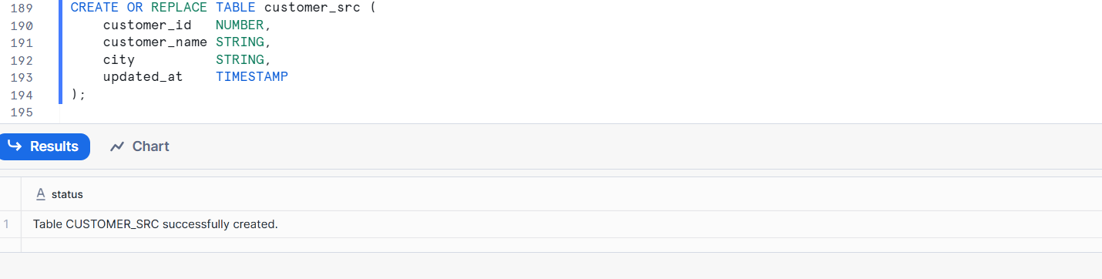
Verify the table
DESC TABLE customer_src;

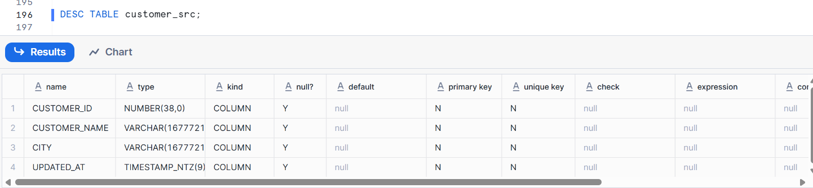
- Insert multiple records per customer with different timestamps.
Insert multiple records per customer
INSERT INTO customer_src VALUES
(1, 'Ravi', 'Hyderabad', '2025-01-01 10:00:00'),
(1, 'Ravi', 'Bangalore', '2025-01-05 12:30:00'),
(2, 'Anita', 'Chennai', '2025-01-02 09:15:00'),
(2, 'Anita', 'Mumbai', '2025-01-06 14:45:00'),
(3, 'Suresh','Pune', '2025-01-03 11:00:00');
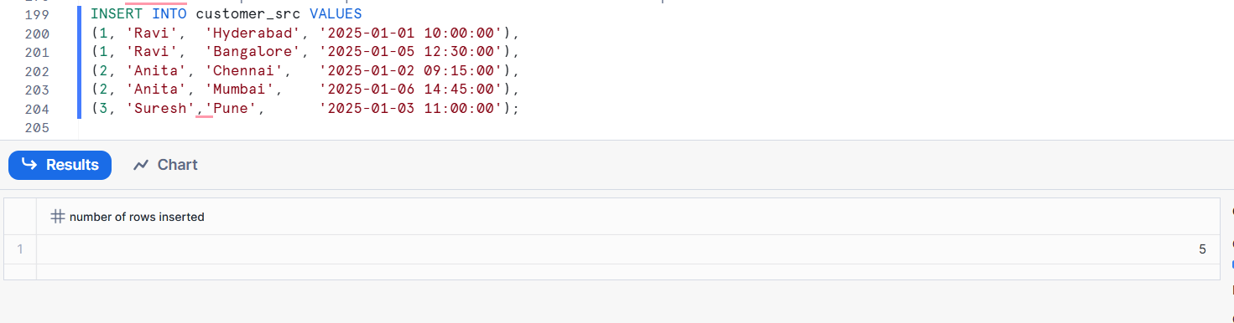
Verify the data
SELECT * FROM customer_src
ORDER BY customer_id, updated_at;
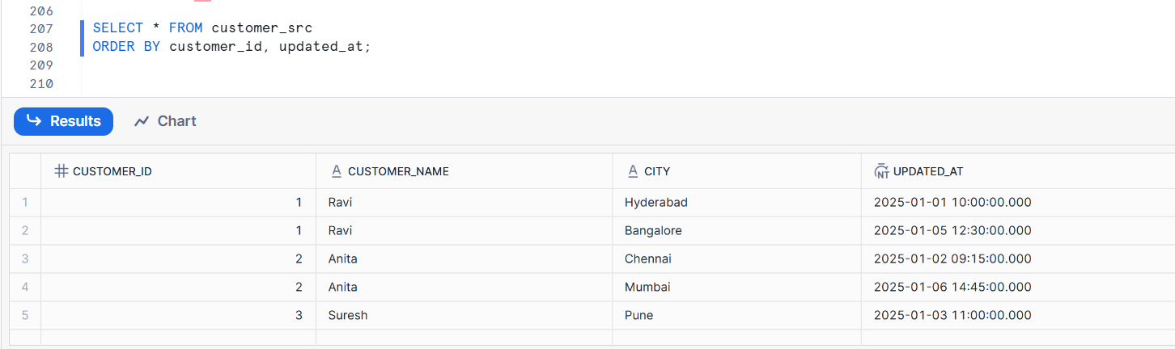
Each row has a different timestamp
- Create a Dynamic Table customer_dim_scd1_dt that keeps only the latest record per customer.
Create the Dynamic Table customer_dim_scd1_dt
CREATE OR REPLACE DYNAMIC TABLE customer_dim_scd1_dt
TARGET_LAG = '1 MINUTE'
WAREHOUSE = COMPUTE_WH
AS
SELECT
customer_id,
customer_name,
city,
updated_at
FROM customer_src
QUALIFY ROW_NUMBER() OVER (
PARTITION BY customer_id
ORDER BY updated_at DESC
) = 1;
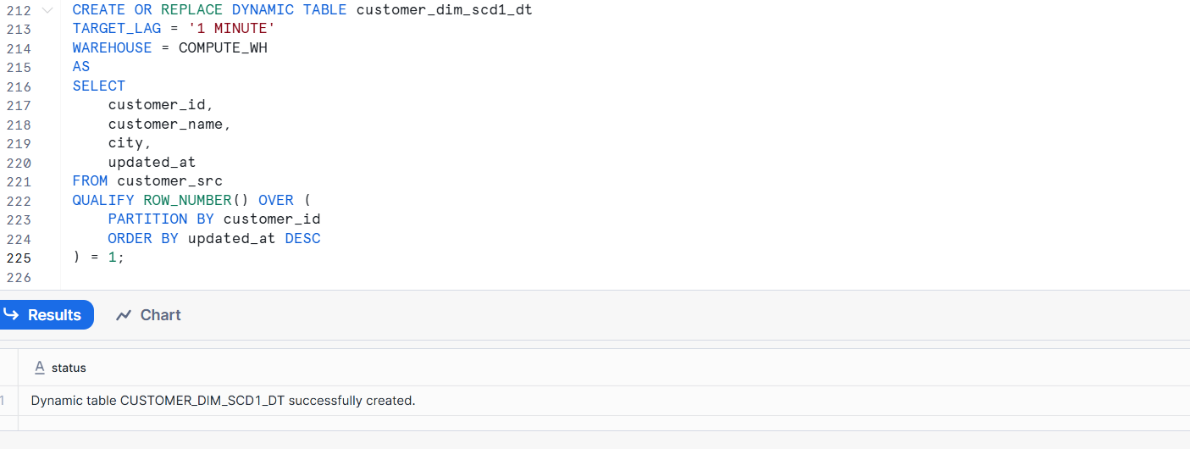
Verify the Dynamic Table
SELECT * FROM customer_dim_scd1_dt
ORDER BY customer_id;
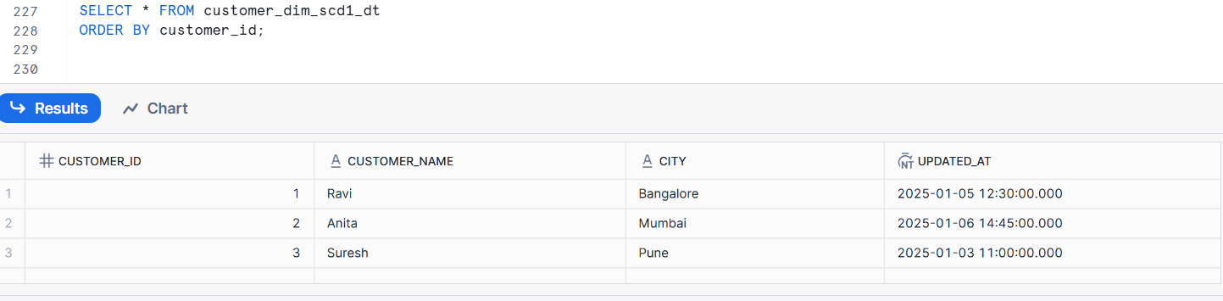
Keeps only the latest row for each customer
Older records are automatically replaced
Updates happen without manual scheduling

- Insert a new version of an existing customer and verify that old data disappears.
Insert a new version of an existing customer
INSERT INTO customer_src VALUES
(1, 'Ravi', 'Delhi', '2025-01-10 18:00:00');
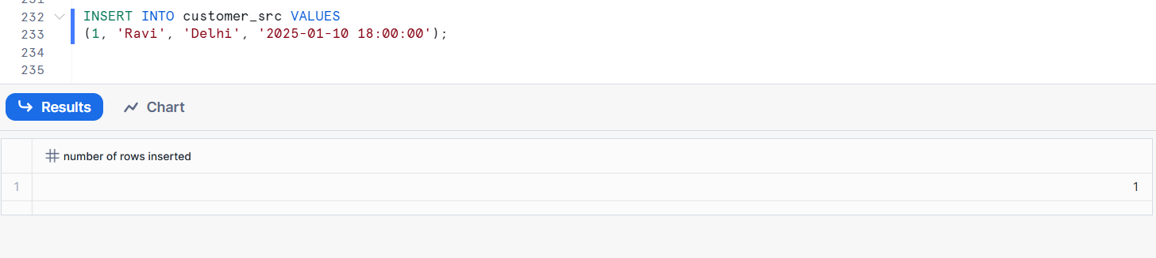
Check source table
SELECT * FROM customer_src
WHERE customer_id = 1
ORDER BY updated_at;
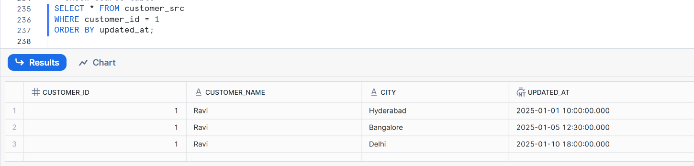
Verify the Dynamic Table
SELECT * FROM customer_dim_scd1_dt
WHERE customer_id = 1;
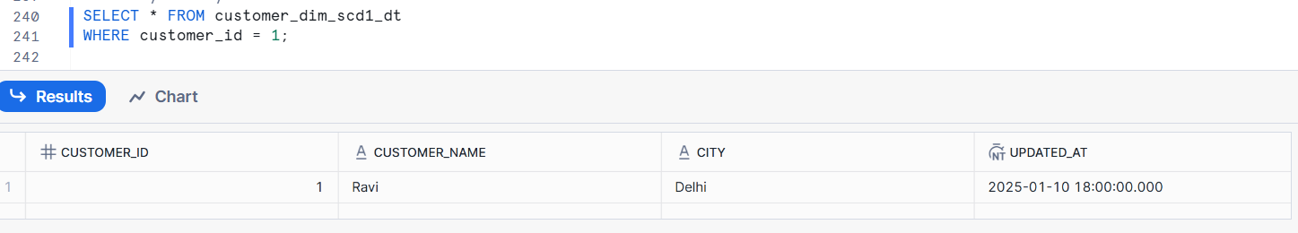
Only one record for customer_id = 1
City shows Delhi (latest)
Older city values disappear

Part 4: Stored Procedures – ETL Practice
- Create a target table orders_audit.
Create the target table orders_audit
CREATE OR REPLACE TABLE orders_audit (
order_id NUMBER,
action_type STRING,
action_time TIMESTAMP
);
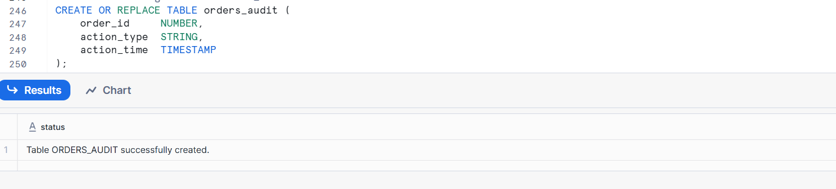
Verify the table
DESC TABLE orders_audit;
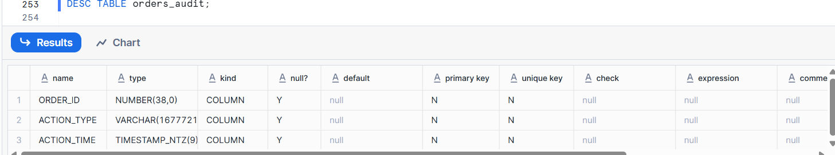
- Write a Stored Procedure that:
- Inserts rows into orders_audit
Create the Stored Procedure

CREATE OR REPLACE PROCEDURE
insert_orders_audit(
p_order_id NUMBER,
p_action_type STRING
)
RETURNS STRING
LANGUAGE SQL
AS
$$
BEGIN
INSERT INTO orders_audit
VALUES (:p_order_id, :p_action_type, CURRENT_TIMESTAMP);

RETURN 'Audit record inserted';

END;
$$;

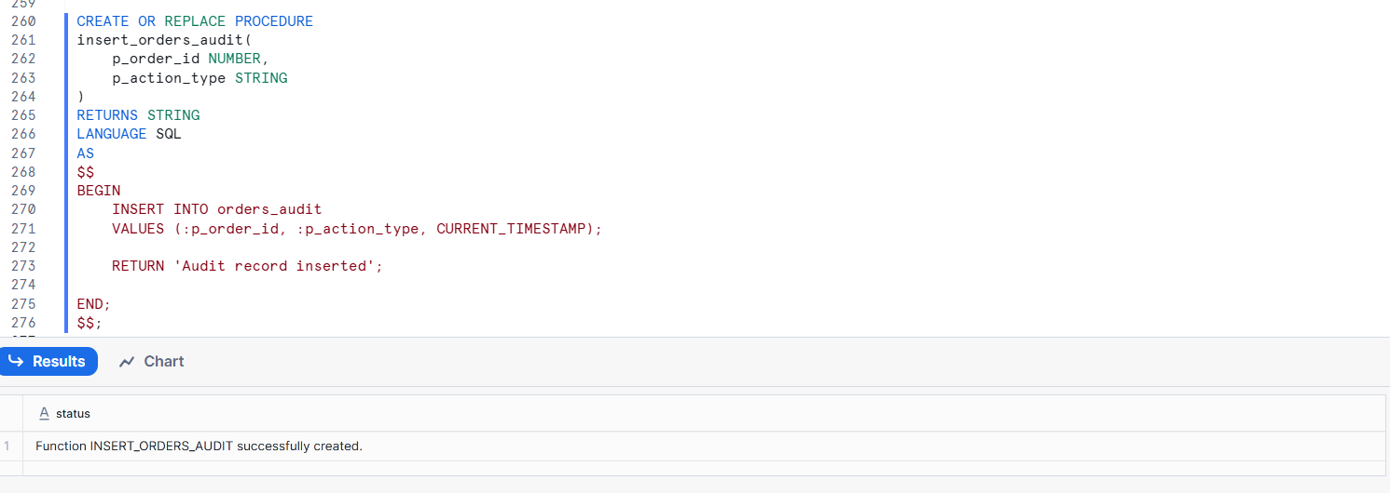
Call the procedure

CALL insert_orders_audit ('103', 'INSERT');
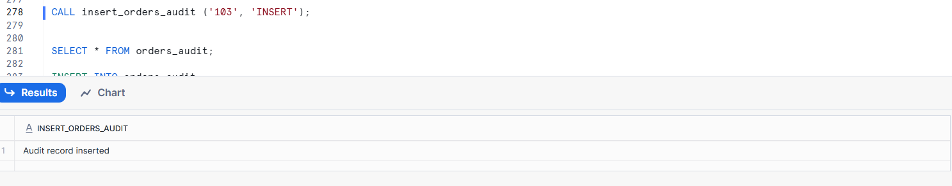
- Captures load timestamp
Create a table with load timestamp
CREATE OR REPLACE TABLE orders_load_example (
order_id NUMBER,
product STRING,
amount NUMBER,
load_ts TIMESTAMP DEFAULT CURRENT_TIMESTAMP
);
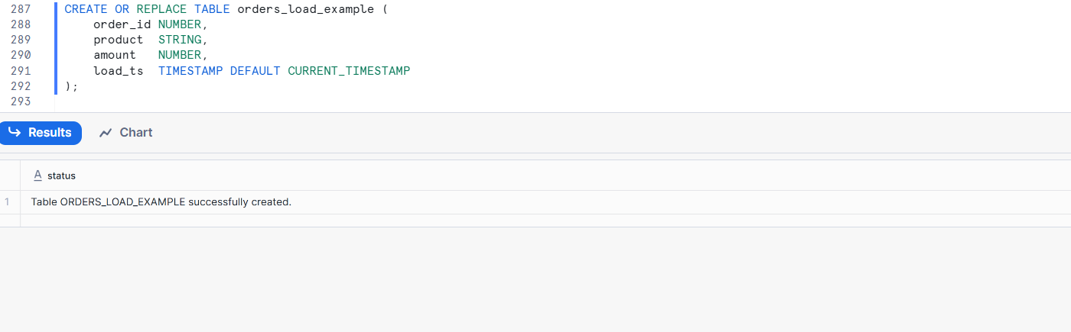
Insert data
INSERT INTO orders_load_example (order_id, product, amount)
VALUES (1, 'Laptop', 50000);
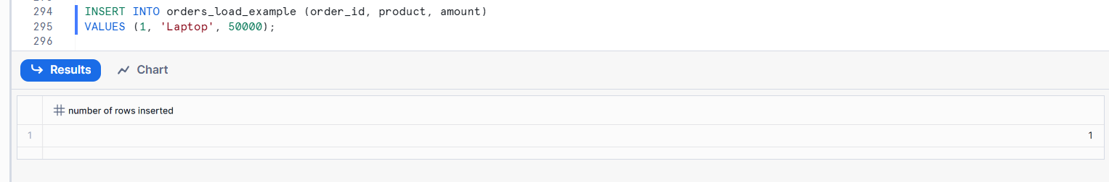
Query the table
SELECT * FROM orders_load_example;
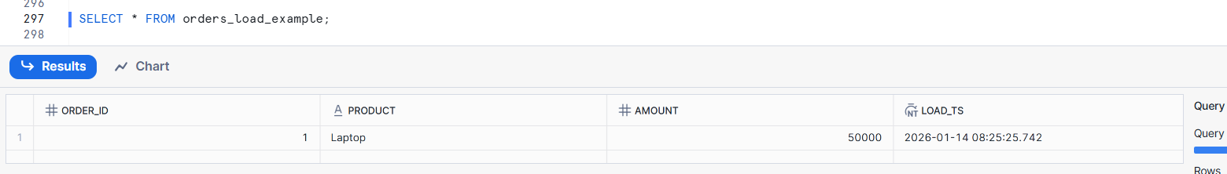
did not insert load_ts manually
Snowflake automatically stored the load time
Each row knows when it was loaded

- Captures record count
Create an audit table to store record counts
CREATE OR REPLACE TABLE load_audit (
table_name STRING,
record_count NUMBER,
load_time TIMESTAMP DEFAULT CURRENT_TIMESTAMP
);

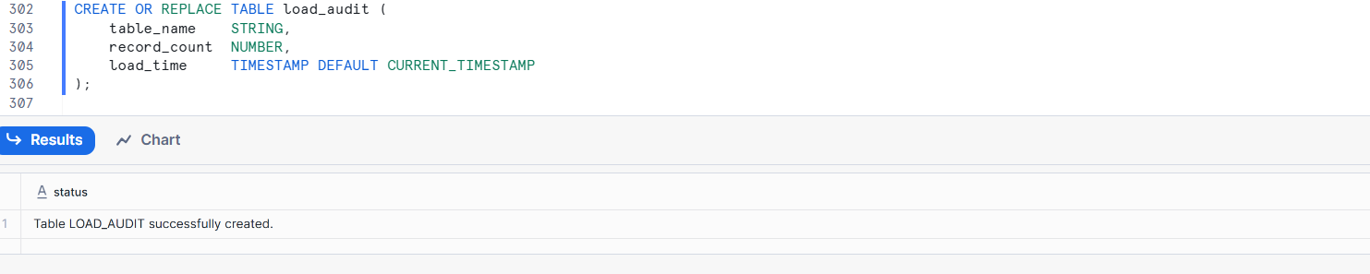
Insert data into a target table
INSERT INTO orders_src
SELECT * FROM orders_src;
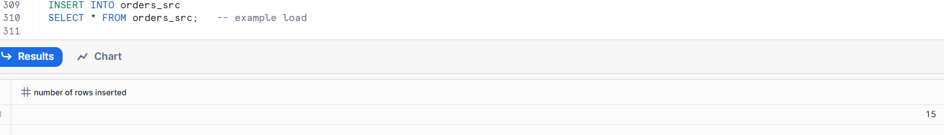
Capture record count after load
INSERT INTO load_audit (table_name, record_count)
SELECT 'orders_src', COUNT(*)
FROM orders_src;
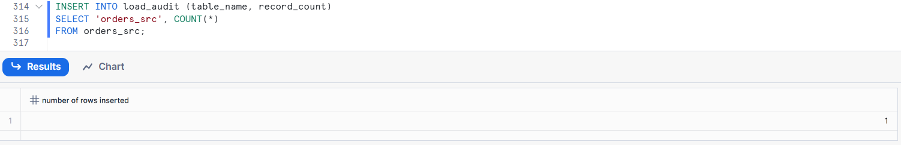
Query the audit table
SELECT * FROM load_audit;
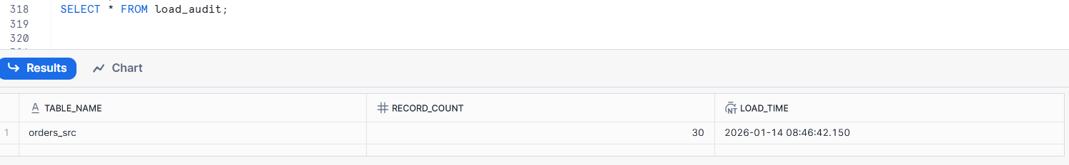
- Execute the Stored Procedure manually.

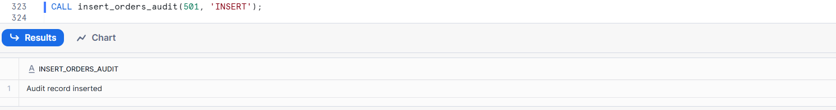

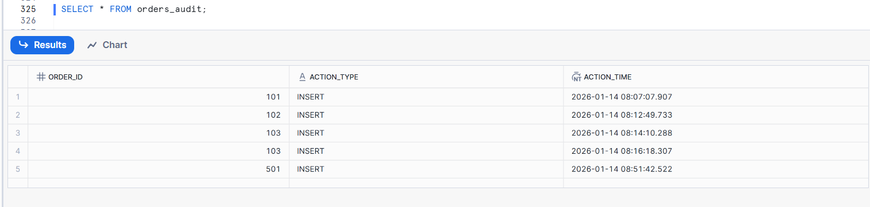
- Modify the Stored Procedure to include basic error handling.
--- Modify the Stored Procedure
CREATE OR REPLACE PROCEDURE insert_orders_audit(
p_order_id NUMBER,
p_action_type STRING
)
RETURNS STRING
LANGUAGE SQL
AS
$$
BEGIN
INSERT INTO orders_audit
VALUES (:p_order_id, :p_action_type, CURRENT_TIMESTAMP);

RETURN 'SUCCESS: Audit record inserted';

EXCEPTION
WHEN OTHER THEN
RETURN 'ERROR: Failed to insert audit record';
END;
$$;
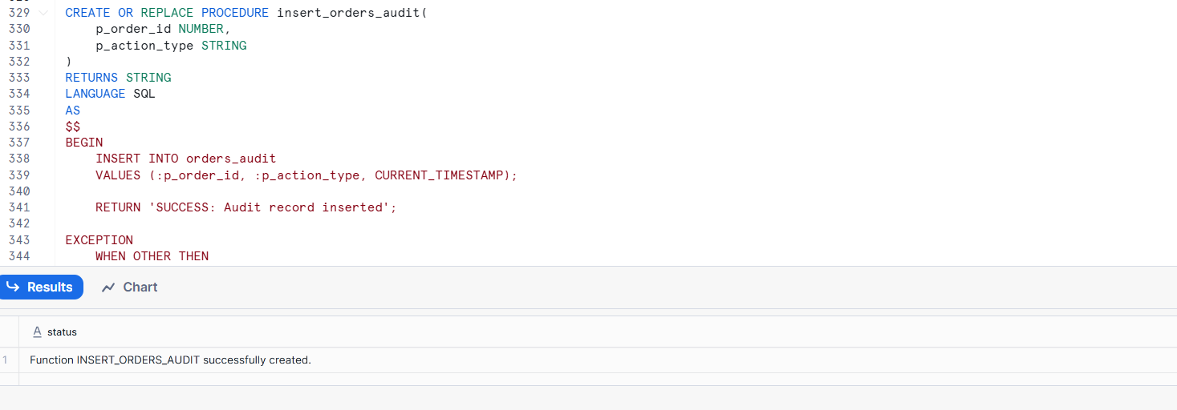
Execute the Stored Procedure
CALL insert_orders_audit(601, 'INSERT');
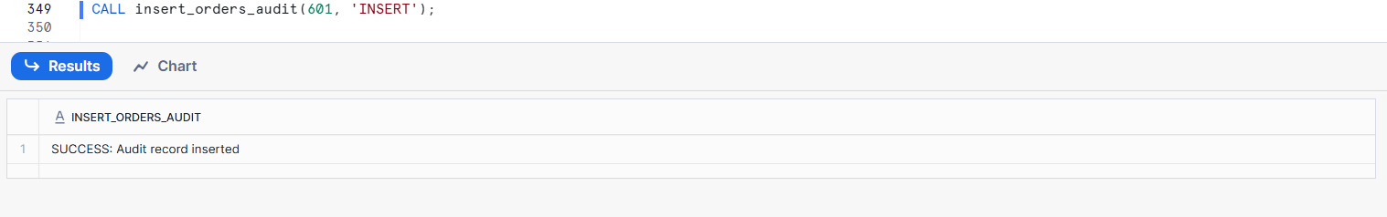
Verify audit table
SELECT * FROM orders_audit;
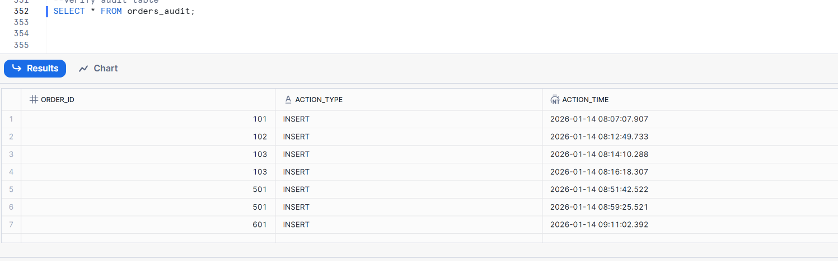
- Schedule the Stored Procedure using a Task.

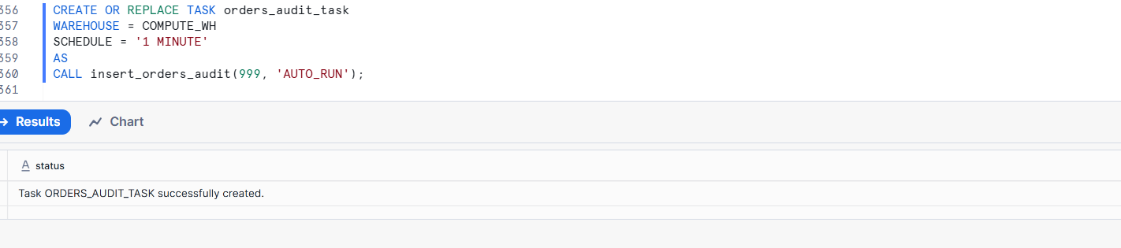

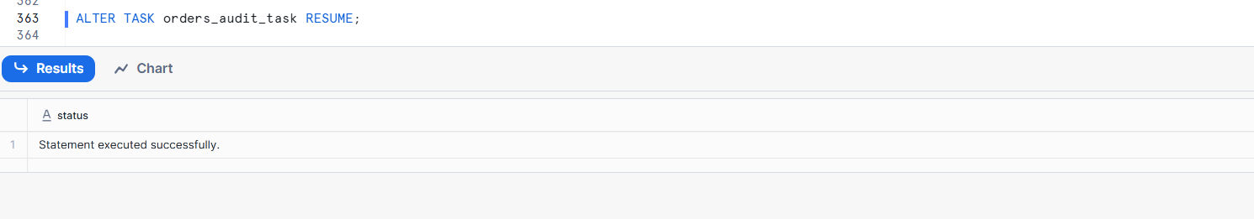

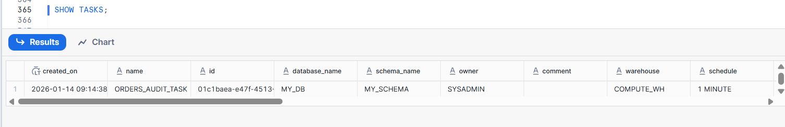

Part 5: Stored Procedures vs Dynamic Tables
- Use a Stored Procedure to:
- Update a flag column in a table conditionally.
Create a table
CREATE OR REPLACE TABLE orders (
order_id INT,
customer_name STRING,
amount NUMBER,
high_value_flag STRING
);

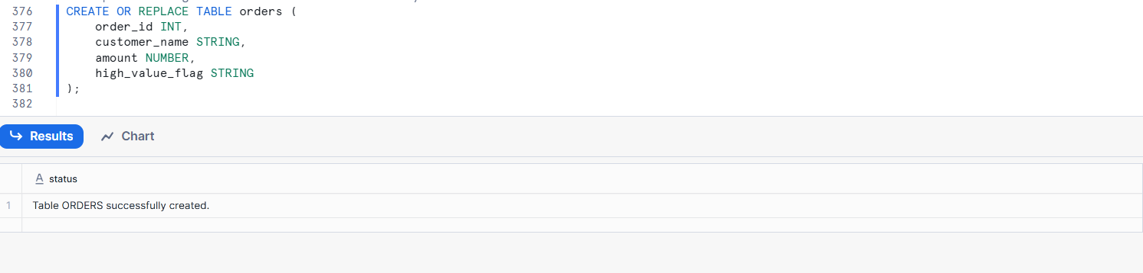
Insert sample data
INSERT INTO orders VALUES
(1, 'Ravi', 500, NULL),
(2, 'Anita', 1500, NULL),
(3, 'Kiran', 2500, NULL),
(4, 'Sita', 800, NULL);
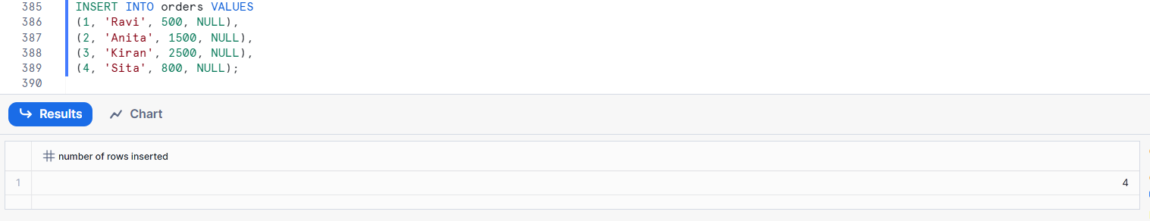
Check data:
SELECT * FROM orders;
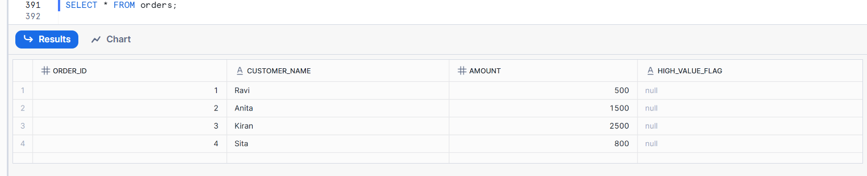
Create Stored Procedure
CREATE OR REPLACE PROCEDURE update_high_value_flag()
RETURNS STRING
LANGUAGE SQL
AS
$$
BEGIN
UPDATE orders
SET high_value_flag = 'Y'
WHERE amount >= 1000;

UPDATE orders
SET high_value_flag = 'N'
WHERE amount < 1000;

RETURN 'Flag updated successfully';
END;
$$;
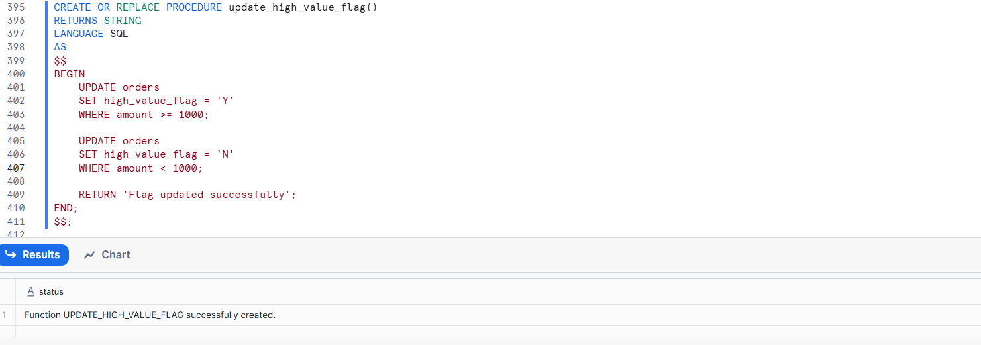
Execute the Stored Procedure
CALL update_high_value_flag();
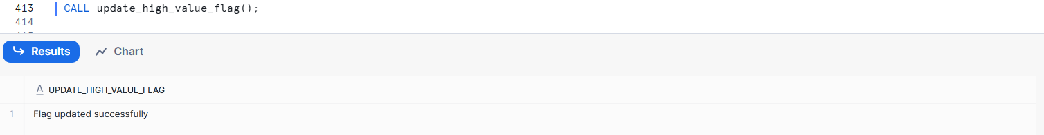
Verify the result
SELECT * FROM orders;
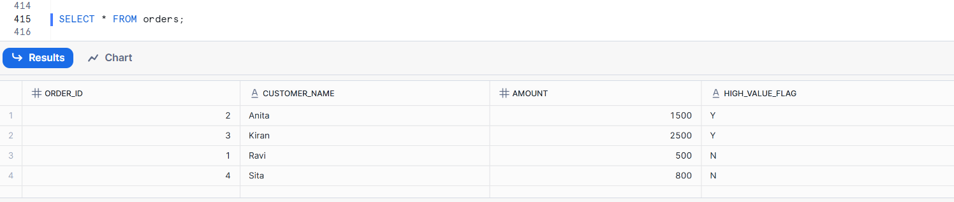
- Try implementing the same logic using a Dynamic Table.
Note the limitation.
Dynamic Tables cannot update data directly. They only derive data using SELECT logic, so conditional flags must be calculated using CASE expressions, not UPDATE statements.

Create a table
CREATE OR REPLACE TABLE orders (
order_id INT,
customer_name STRING,
amount NUMBER,
high_value_flag STRING
);

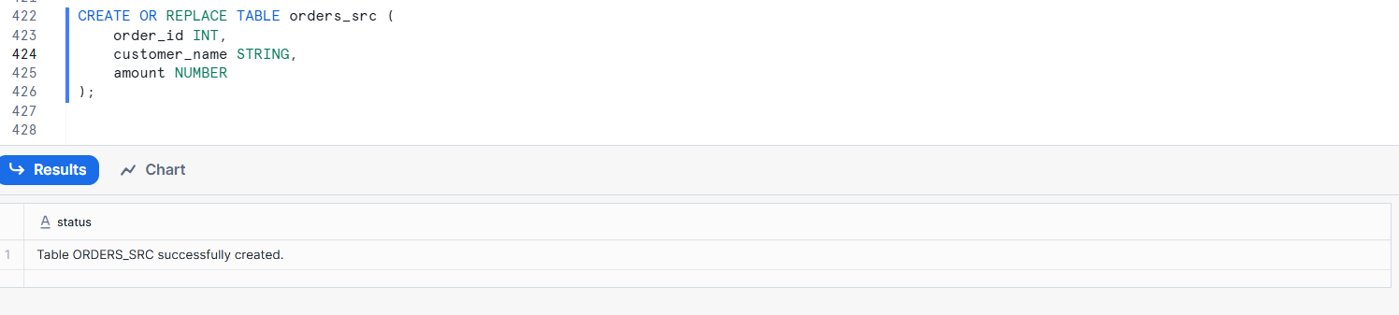
Insert sample data
INSERT INTO orders VALUES
(1, 'Ravi', 500, NULL),
(2, 'Anita', 1500, NULL),
(3, 'Kiran', 2500, NULL),
(4, 'Sita', 800, NULL);
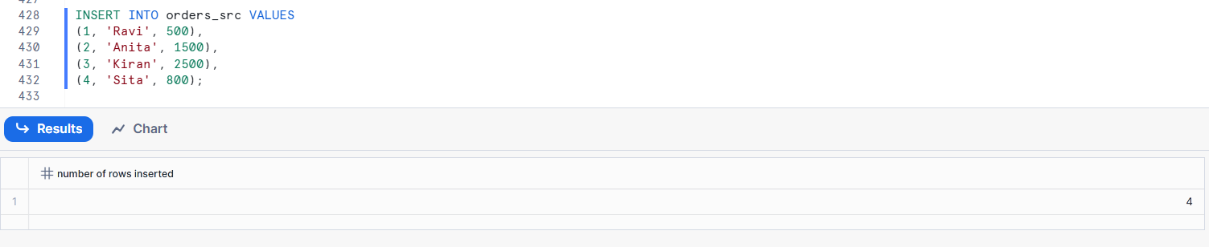
Check data:
SELECT * FROM orders;
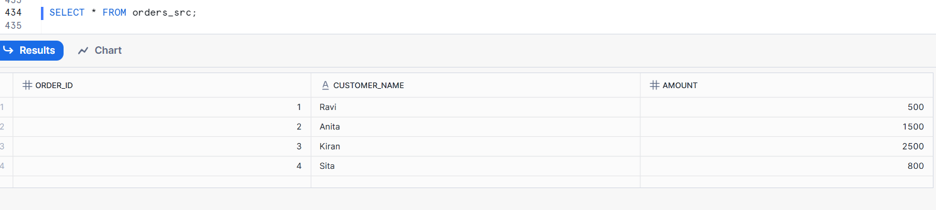
Create Dynamic Table with conditional logic
CREATE OR REPLACE DYNAMIC TABLE orders_flag_dt
TARGET_LAG = '5 MINUTE'
WAREHOUSE = COMPUTE_WH
AS
SELECT
order_id,
customer_name,
amount,
CASE
WHEN amount >= 1000 THEN 'Y'
ELSE 'N'
END AS high_value_flag
FROM orders_src;
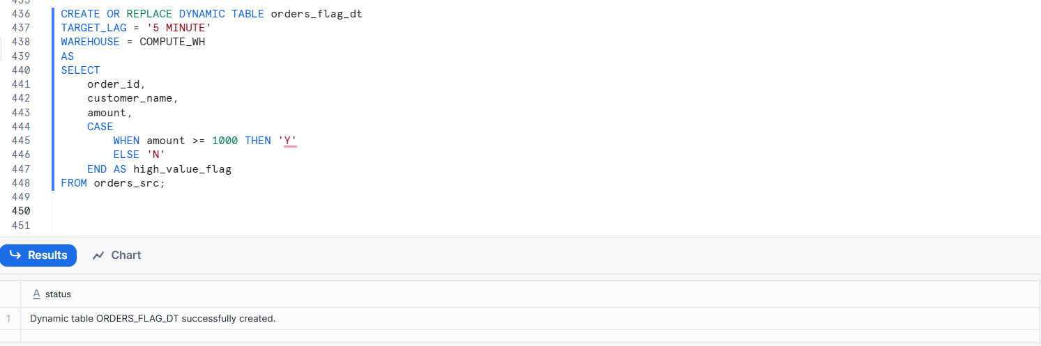
- Dynamic Tables do NOT allow UPDATE
- Instead, we derive the flag using CASE WHEN
Query the Dynamic Table
SELECT * FROM orders_flag_dt;
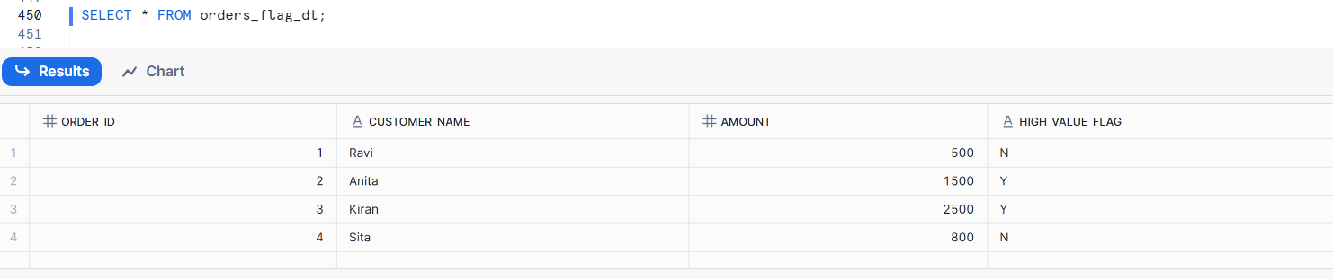
Modify source data
UPDATE orders_src
SET amount = 1200
WHERE order_id = 1;
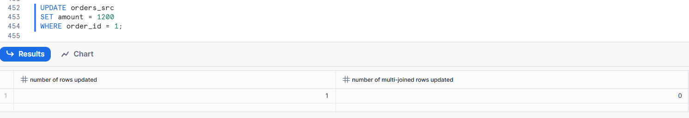

Limitation of Dynamic Tables
UPDATE orders_flag_dt
SET high_value_flag = 'Y';
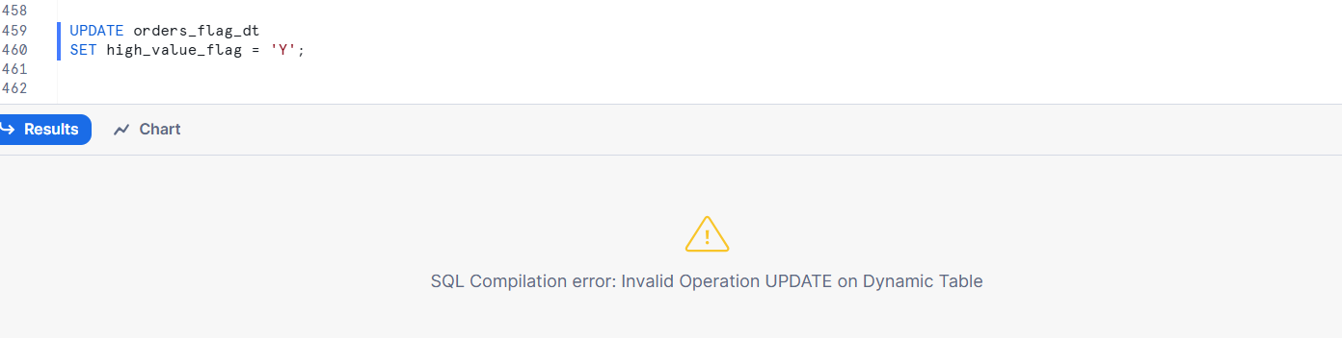
Why?
Because:
- Dynamic Tables are read-only
- They are derived objects
- They recalculate, not store business logic updates

Part 6: Dashboard-Ready Queries
- Write a query on orders_region_summary_dt for:
- Total sales by region
Total sales by region
SELECT
region,
total_sales
FROM orders_region_summary_dt
ORDER BY total_sales DESC;
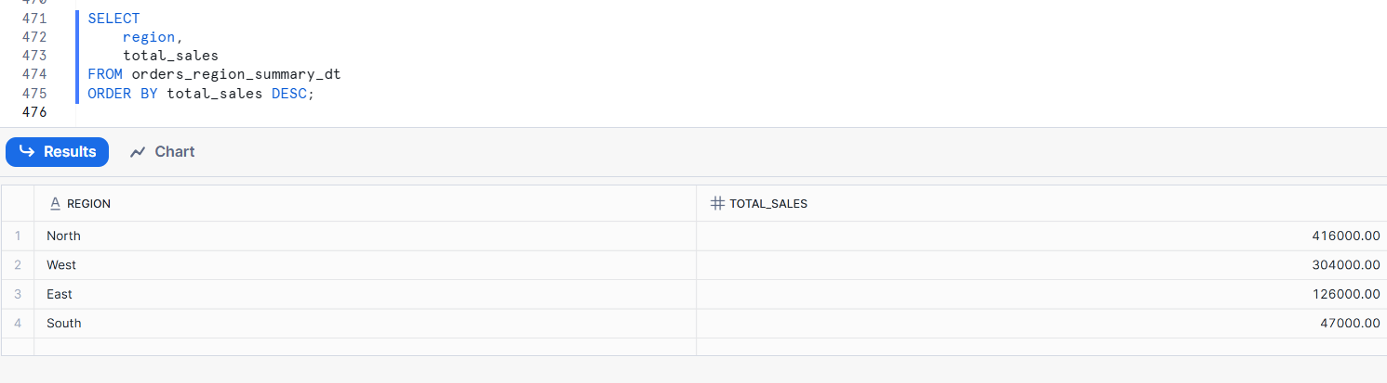
- Write a query on orders_product_kpi_dt for:
- Top 3 products by sales.
- Filter dashboard data for:
- Region = 'US'
- Product = 'Laptop'
Create Order_src
CREATE OR REPLACE TABLE orders_src (
"Region" STRING,
"Product" STRING,
"Amount" Number
);
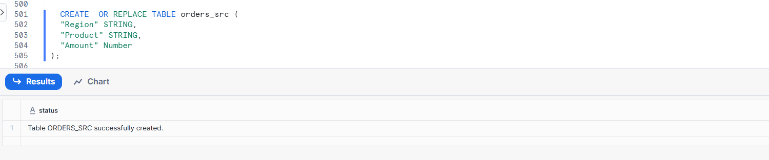
Insert Data
INSERT INTO orders_src ("Region", "Product", "Amount")
VALUES
('US', 'Laptop', 1200),
('US', 'Laptop', 1800),
('US', 'Mobile', 900),
('IN', 'Laptop', 1500);
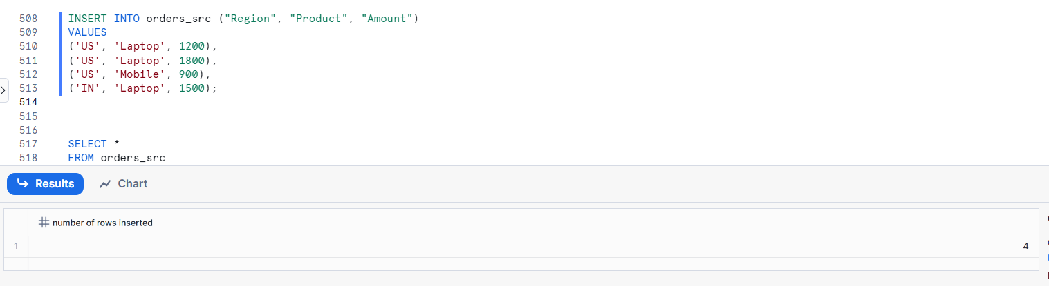
only sales-related fields

SELECT
"Region",
"Product",
SUM("Amount") AS total_sales
FROM orders_src
WHERE "Region" = 'US'
AND "Product" = 'Laptop'
GROUP BY "Region", "Product";
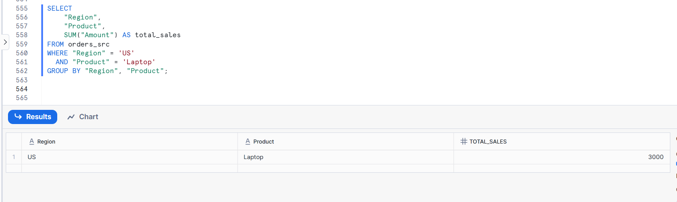

Part 7: Monitoring & Operations
- Query INFORMATION_SCHEMA to:
- Check Dynamic Table freshness.

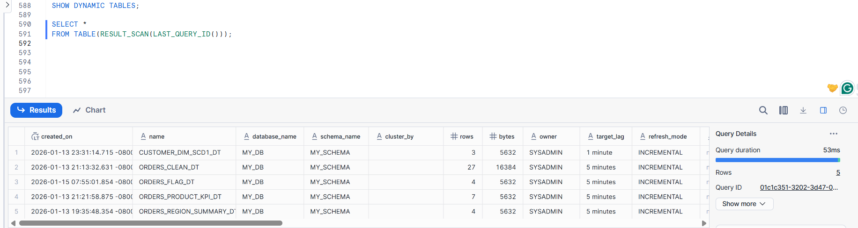
- LAST_QUERY_ID()
- Returns the ID of the last successfully executed query
- RESULT_SCAN(LAST_QUERY_ID())
- Read the result of the last query and treat it like a table.
- Identify last refresh time.
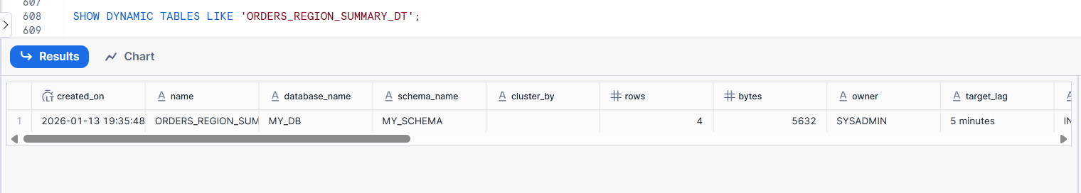

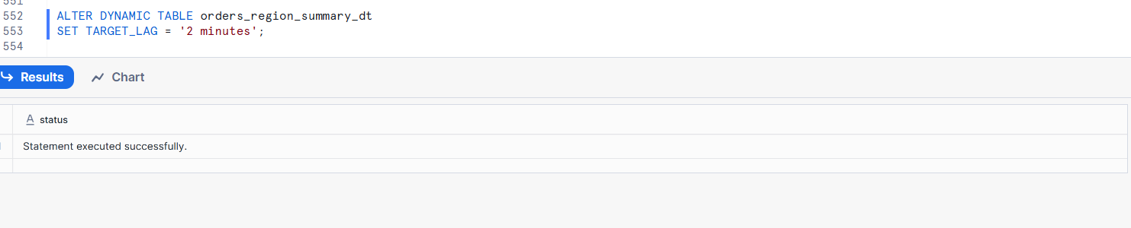
- Change TARGET_LAG to a higher value and observe refresh behavior.
ALTER DYNAMIC TABLE orders_region_summary_dt
SET TARGET_LAG = '15 minutes';
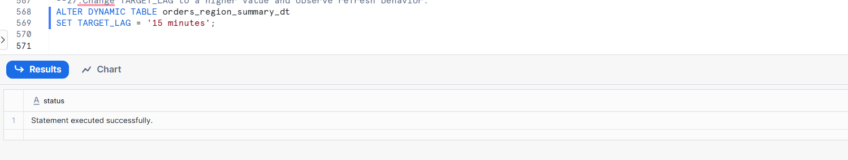
- Separate compute by assigning:
- One warehouse for ETL
CREATE OR REPLACE WAREHOUSE etl_wh
WITH
WAREHOUSE_SIZE = 'SMALL'
AUTO_SUSPEND = 60
AUTO_RESUME = TRUE
INITIALLY_SUSPENDED = TRUE;
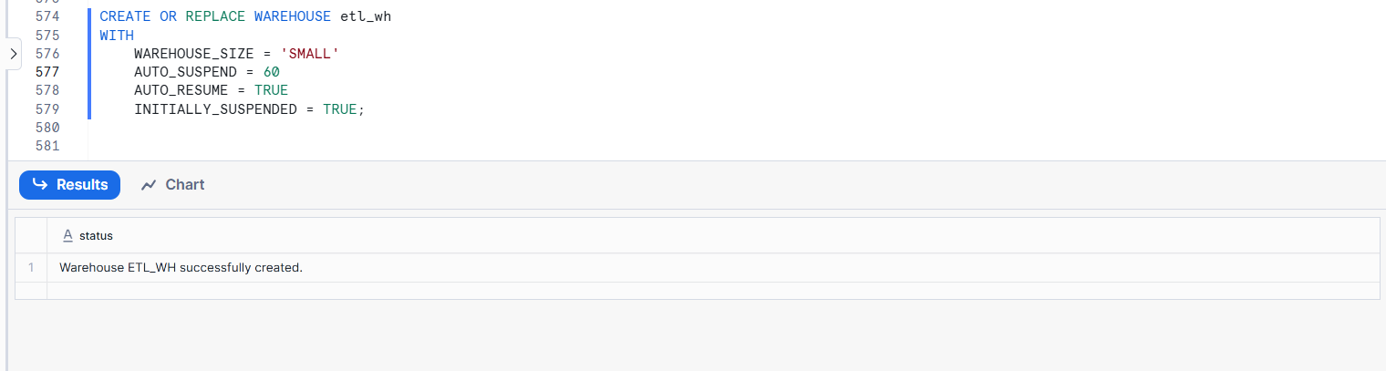
- One warehouse for Dynamic Tables
CREATE OR REPLACE WAREHOUSE dt_wh
WITH
WAREHOUSE_SIZE = 'SMALL'
AUTO_SUSPEND = 60
AUTO_RESUME = TRUE
INITIALLY_SUSPENDED = TRUE;

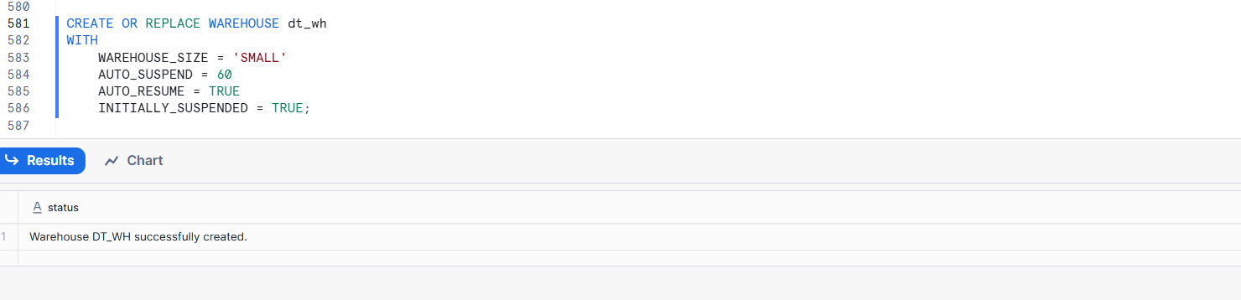
Used only by Dynamic Tables
Auto-suspend saves cost
Independent scaling from ETL/BI warehouses
Assign ETL warehouse to a Dynamic Table
ALTER DYNAMIC TABLE orders_region_summary_dt
SET WAREHOUSE = etl_wh;
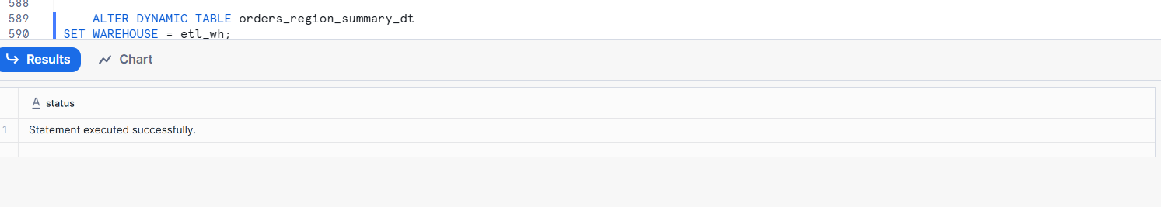
Assign the warehouse to a Dynamic Table
ALTER DYNAMIC TABLE orders_region_summary_dt
SET WAREHOUSE = dt_wh;
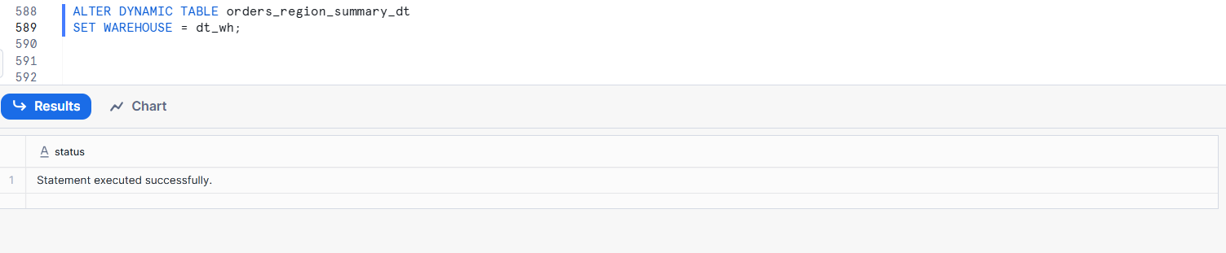

Part 8: Failure & Recovery Practice
- Introduce invalid SQL in a Dynamic Table definition and observe behavior.
Create Dynamic Table
CREATE OR REPLACE DYNAMIC TABLE error_test_dt
TARGET_LAG = '5 minutes'
WAREHOUSE = dt_wh
AS
SELECT
"Region",
SUM("Amount") AS total_sales
FROM orders_src
GROUP BY "Region";
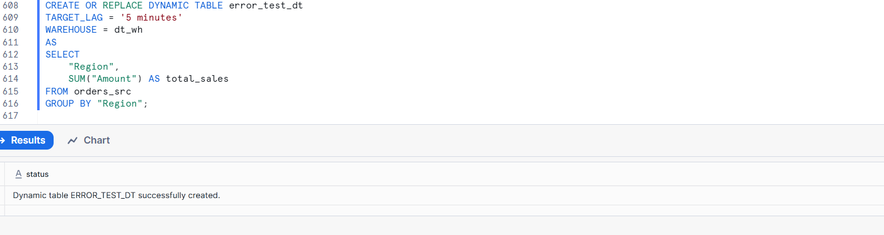
- Fix the issue and confirm auto-recovery.
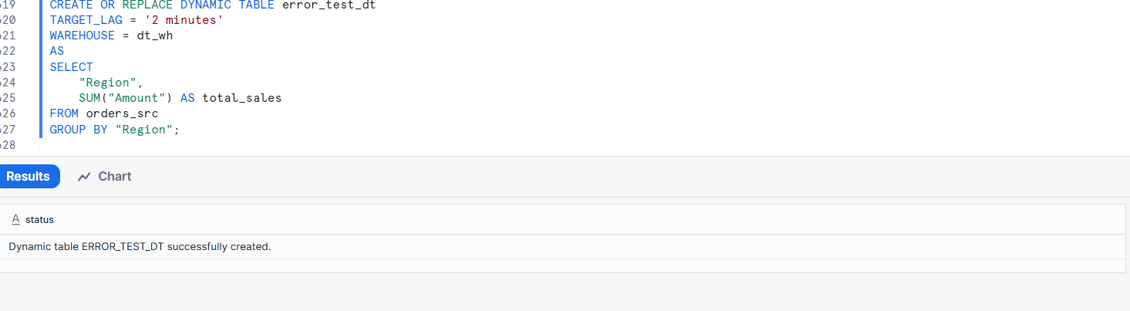
Step 3: Auto-recovery behavior
- Snowflake automatically re-runs refresh
- Dynamic Table state changes from FAILED → ACTIVE
- Data is refreshed without manual intervention

- Stop the Task running the Stored Procedure and restart it.

A. KPI-Driven Dashboard Questions
- Create a Dynamic Table that shows:
  - Today’s sales
  - Yesterday’s sales
  - % change day-over-day

Create the Dynamic Table
CREATE OR REPLACE DYNAMIC TABLE daily_sales_kpi_dt
TARGET_LAG = '2 minutes'
WAREHOUSE = dt_wh
AS
SELECT
/* Today's Sales */
SUM(
CASE
WHEN CAST(order_date AS DATE) = CURRENT_DATE()
THEN "Amount"
ELSE 0
END
) AS todays_sales,

/* Yesterday's Sales */
SUM(
CASE
WHEN CAST(order_date AS DATE) = CURRENT_DATE() - 1
THEN "Amount"
ELSE 0
END
) AS yesterdays_sales,

/* % Day-over-Day Change */
CASE
WHEN SUM(
CASE
WHEN CAST(order_date AS DATE) = CURRENT_DATE() - 1
THEN "Amount"
ELSE 0
END
) = 0
THEN 0
ELSE
(
(
SUM(
CASE
WHEN CAST(order_date AS DATE) = CURRENT_DATE()
THEN "Amount"
ELSE 0
END
)
-
SUM(
CASE
WHEN CAST(order_date AS DATE) = CURRENT_DATE() - 1
THEN "Amount"
ELSE 0
END
)
)
/
SUM(
CASE
WHEN CAST(order_date AS DATE) = CURRENT_DATE() - 1
THEN "Amount"
ELSE 0
END
)
) * 100
END AS day_over_day_pct
FROM orders_src;

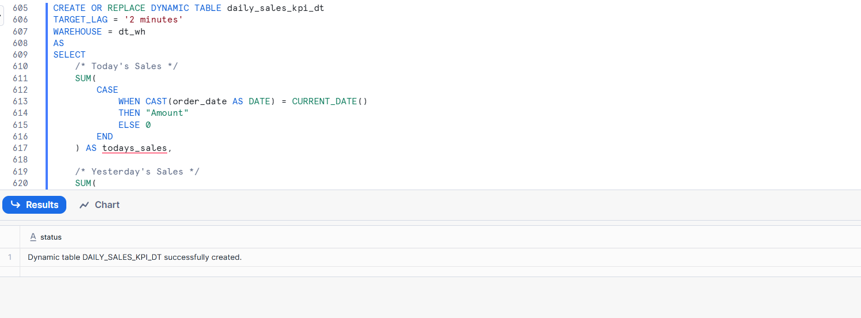
- Build a query that returns:
  - Total sales
  - Average order value
  - Orders count
in one result set for KPI cards.
SELECT
SUM("Amount") AS total_sales,
AVG("Amount") AS avg_order_value,
COUNT(*) AS orders_count
FROM orders_src;

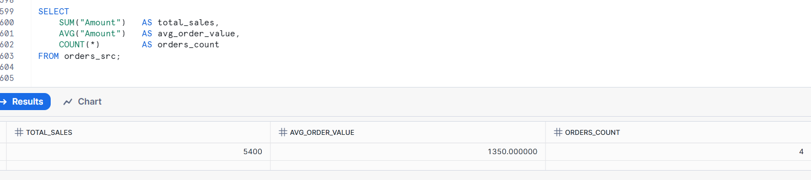
- Design a Dynamic Table that supports:
  - MTD (Month-to-Date) sales
  - YTD (Year-to-Date) sales

CREATE OR REPLACE DYNAMIC TABLE mtd_ytd_sales_dt
TARGET_LAG = '5 minutes'
WAREHOUSE = dt_wh
AS
SELECT
/* MTD Sales */
SUM(
CASE
WHEN YEAR(order_date) = YEAR(CURRENT_DATE())
AND MONTH(order_date) = MONTH(CURRENT_DATE())
THEN "Amount"
ELSE 0
END
) AS mtd_sales,

/* YTD Sales */
SUM(
CASE
WHEN YEAR(order_date) = YEAR(CURRENT_DATE())
THEN "Amount"
ELSE 0
END
) AS ytd_sales
FROM orders_src;
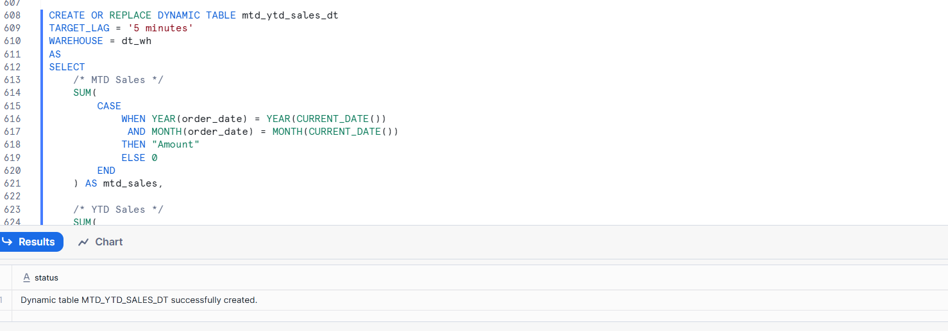
- Create a KPI that turns RED if today’s sales drop below yesterday’s sales.
SELECT
/* Today's Sales */
SUM(
CASE
WHEN CAST(order_date AS DATE) = CURRENT_DATE()
THEN "Amount"
ELSE 0
END
) AS todays_sales,

/* Yesterday's Sales */
SUM(
CASE
WHEN CAST(order_date AS DATE) = CURRENT_DATE() - 1
THEN "Amount"
ELSE 0
END
) AS yesterdays_sales,

/* KPI Status */
CASE
WHEN
SUM(CASE
WHEN CAST(order_date AS DATE) = CURRENT_DATE()
THEN "Amount"
ELSE 0
END)
<
SUM(CASE
WHEN CAST(order_date AS DATE) = CURRENT_DATE() - 1
THEN "Amount"
ELSE 0
END)
THEN 'RED'
ELSE 'GREEN'
END AS kpi_status
FROM orders_src;

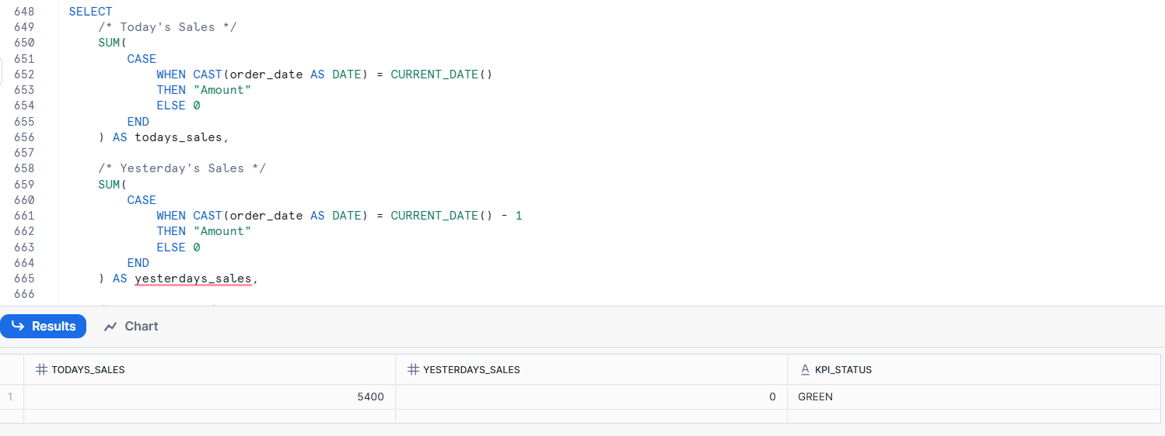

B. Trend & Time-Series Dashboard Questions
- Create a Dynamic Table that aggregates:
  - Daily sales trend for the last 30 days.
CREATE OR REPLACE DYNAMIC TABLE daily_sales_trend_30d_dt
TARGET_LAG = '5 minutes'
WAREHOUSE = dt_wh
AS
SELECT
CAST(order_date AS DATE) AS sales_date,
SUM("Amount") AS daily_sales
FROM orders_src
WHERE CAST(order_date AS DATE) >= CURRENT_DATE() - 30
GROUP BY CAST(order_date AS DATE)
ORDER BY sales_date;
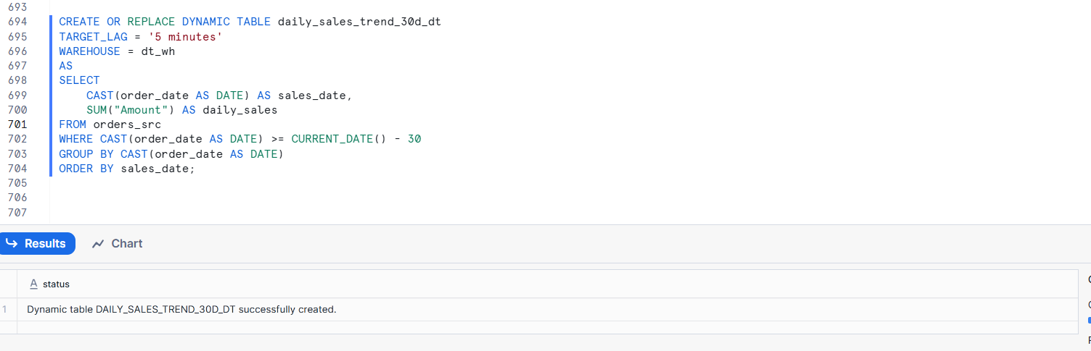
- Build a query that supports:
  - Rolling 7-day average sales.
Day Average Query
SELECT
order_date,
SUM("Amount") AS daily_sales,

/* Rolling 7-day average */
AVG(SUM("Amount")) OVER (
ORDER BY order_date
ROWS BETWEEN 6 PRECEDING AND CURRENT ROW
) AS rolling_7_day_avg
FROM orders_src
GROUP BY order_date
ORDER BY order_date;
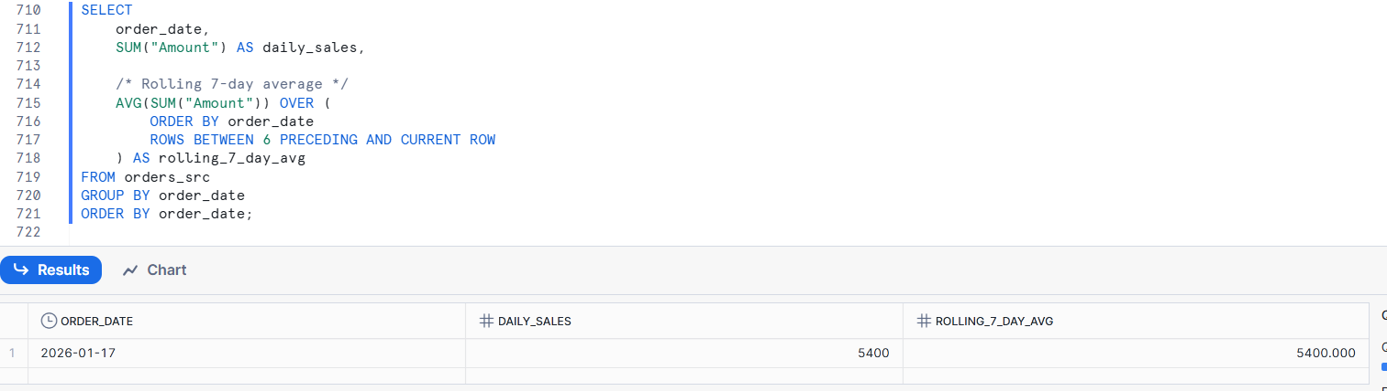
- Design a dashboard query that allows users to:
  - Switch between daily, weekly, and monthly views.
-Daily view
SELECT
DATE_TRUNC('DAY', order_date) AS time_period,
SUM("Amount") AS total_sales
FROM orders_src
GROUP BY time_period
ORDER BY time_period;
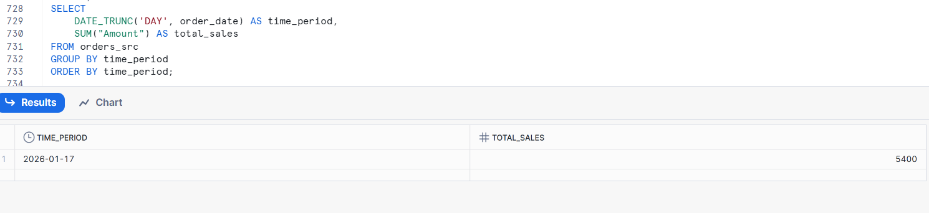
Weekly view
SELECT
DATE_TRUNC('WEEK', order_date) AS time_period,
SUM("Amount") AS total_sales
FROM orders_src
GROUP BY time_period
ORDER BY time_period;

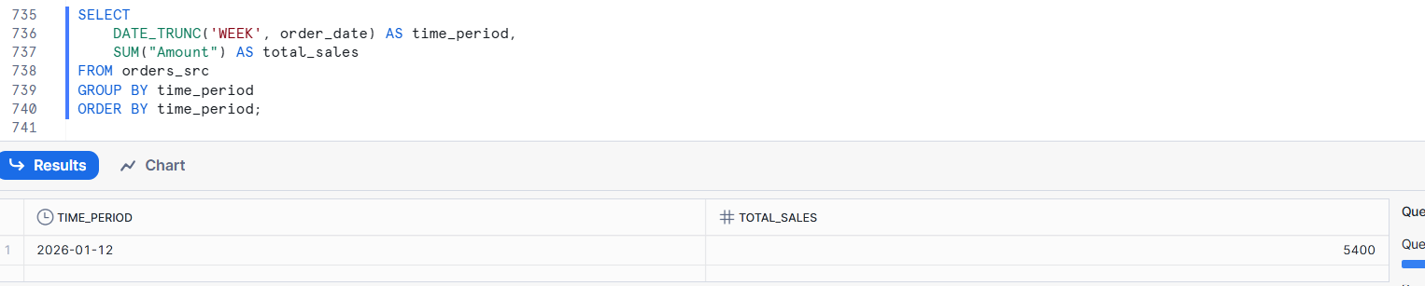
Monthly view
SELECT
DATE_TRUNC('MONTH', order_date) AS time_period,
SUM("Amount") AS total_sales
FROM orders_src
GROUP BY time_period
ORDER BY time_period;
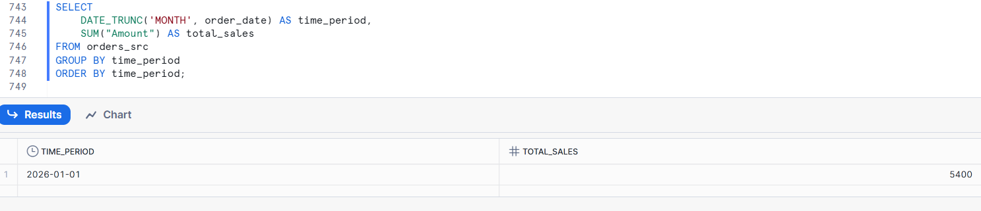
8.Create a Dynamic Table that identifies:
  - Peak sales day per region.
CREATE OR REPLACE DYNAMIC TABLE peak_sales_day_region_dt
TARGET_LAG = '2 minutes'
WAREHOUSE = dt_wh
AS
SELECT
"Region",
order_date,
total_sales
FROM (
SELECT
"Region",
order_date,
SUM("Amount") AS total_sales,
ROW_NUMBER() OVER (
PARTITION BY "Region"
ORDER BY SUM("Amount") DESC
) AS rn
FROM orders_src
GROUP BY "Region", order_date
)
WHERE rn = 1;

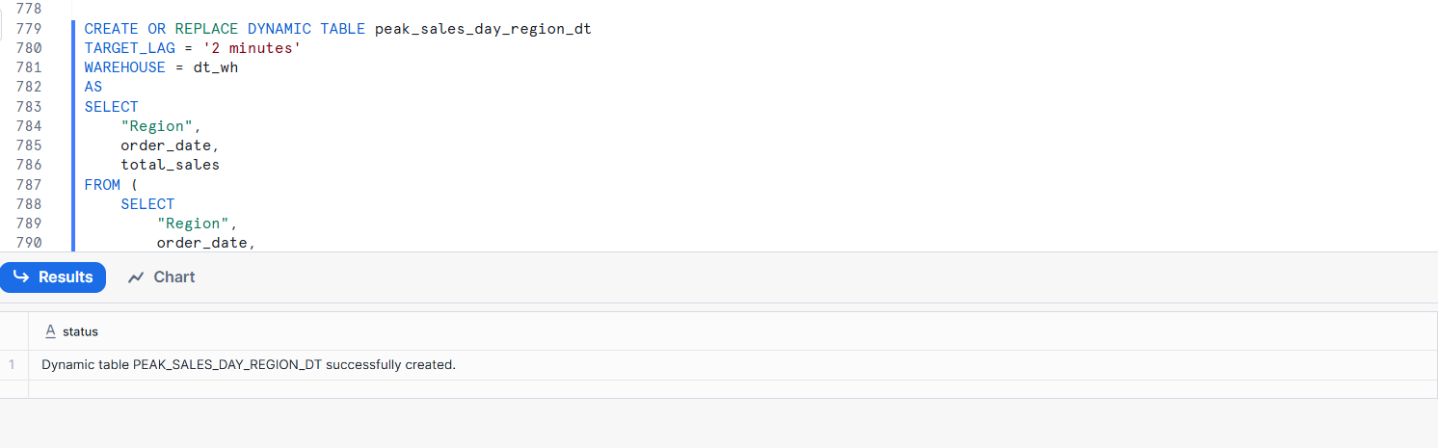

C. Drill-Down & Interactive Dashboard Questions
- Design a Dynamic Table that allows drill-down:
  - Region → Country → City.
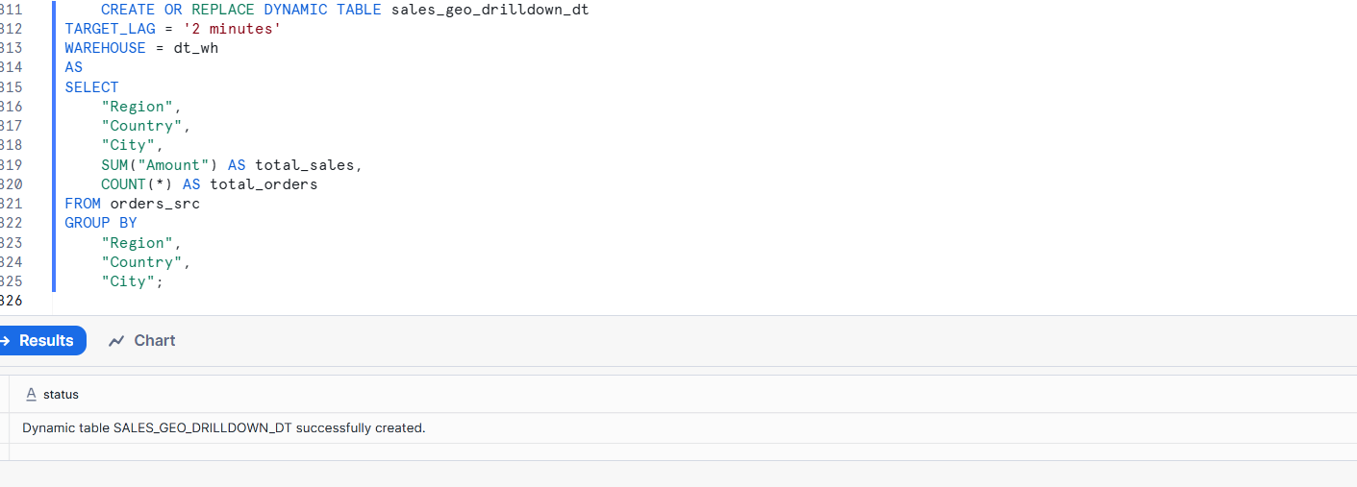
Region level

SELECT
"Region",
SUM(total_sales) AS region_sales
FROM sales_geo_drilldown_dt
GROUP BY "Region";

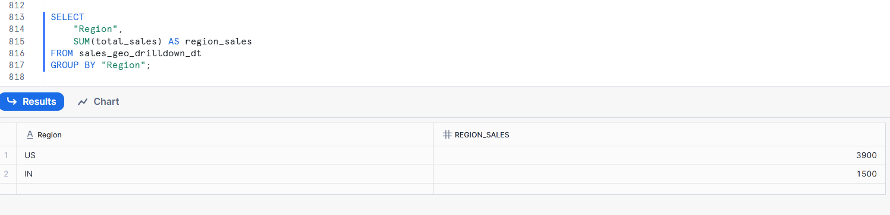
Country level
SELECT
"Region",
"Country",
"City",
total_sales
FROM sales_geo_drilldown_dt
WHERE "Region" = 'US'
AND "Country" = 'USA';
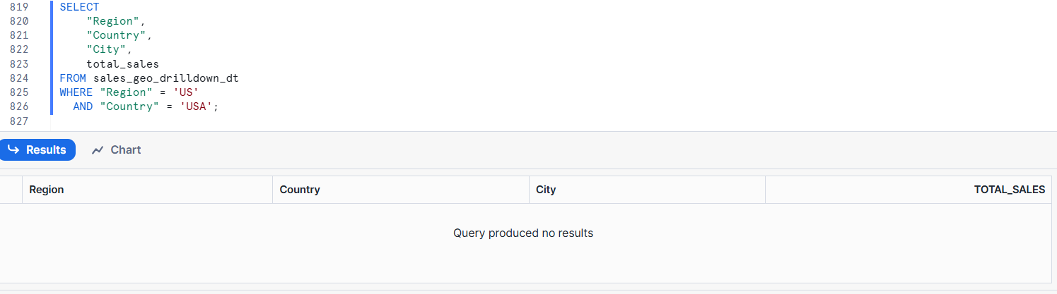
City level
SELECT
"Region",
"Country",
"City",
total_sales
FROM sales_geo_drilldown_dt
WHERE "Region" = 'US'
AND "Country" = 'USA';
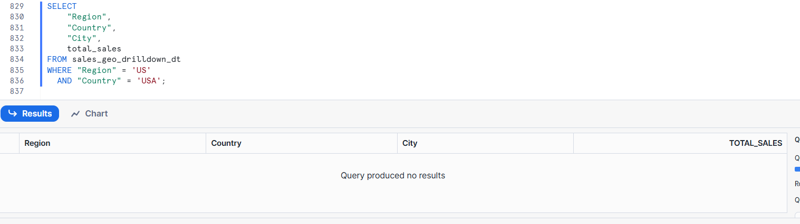
A Dynamic Table was created at the city level, enabling drill-down from Region to Country to City using filters and aggregation
- Create a query that supports:
  - Clicking a region to see product-level sales.

SELECT
"Region",
"Product",
SUM("Amount") AS product_sales
FROM orders_src
WHERE "Region" = 'US'
GROUP BY
"Region",
"Product"
ORDER BY product_sales DESC;

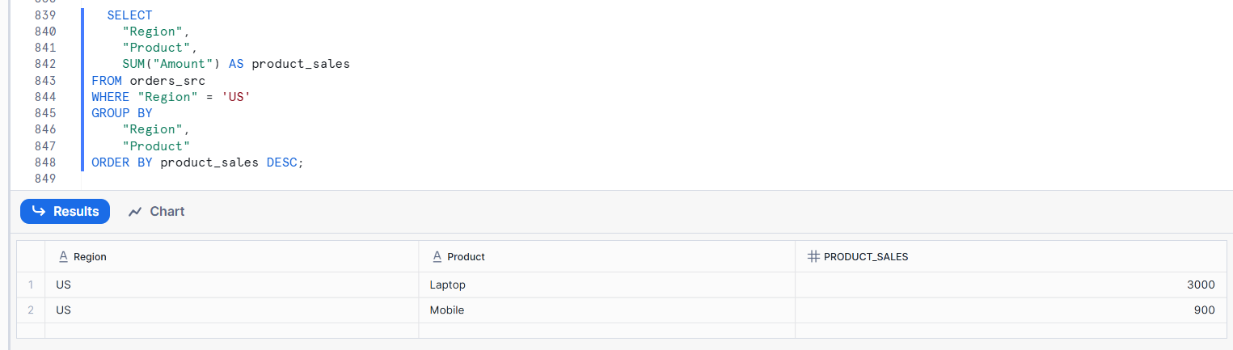
- Build a dashboard dataset that enables:
  - Top-N product selection dynamically.
SELECT
"Product",
SUM("Amount") AS total_sales
FROM orders_src
GROUP BY "Product"
ORDER BY total_sales DESC
LIMIT 5;

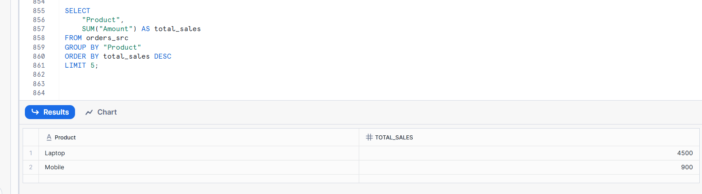
- Create a Dynamic Table that supports:
  - Product category → product → SKU drill-down.
Create Table
CREATE OR REPLACE DYNAMIC TABLE product_drilldown_dt
TARGET_LAG = '2 minutes'
WAREHOUSE = dt_wh
AS
SELECT
"Category",
"Product",
"SKU",
SUM("Amount") AS total_sales,
COUNT(*) AS total_orders
FROM orders_src
GROUP BY
"Category",
"Product",
"SKU";
--Category level
SELECT
"Category",
SUM(total_sales) AS category_sales
FROM product_drilldown_dt
GROUP BY "Category";
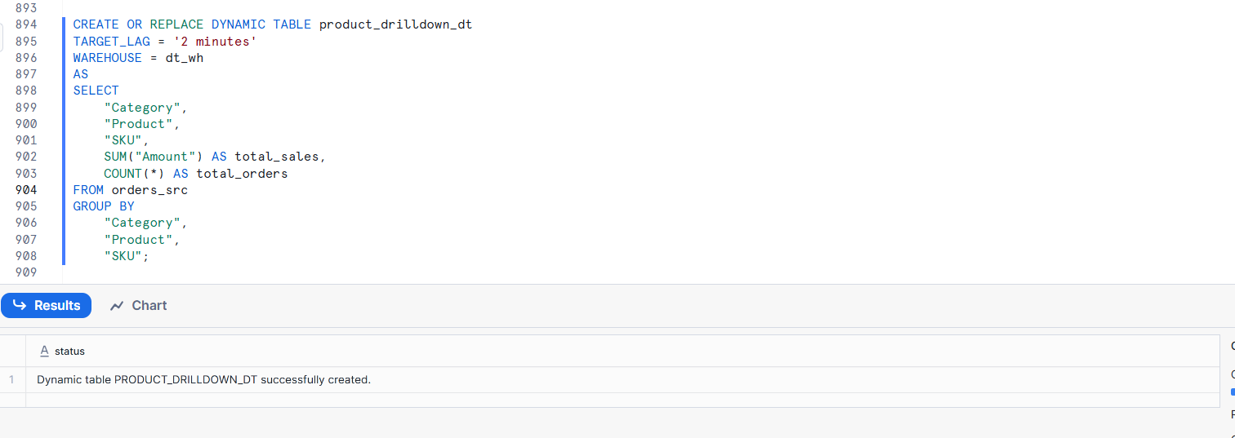
Category level
SELECT
"Category",
SUM(total_sales) AS category_sales
FROM product_drilldown_dt
GROUP BY "Category";
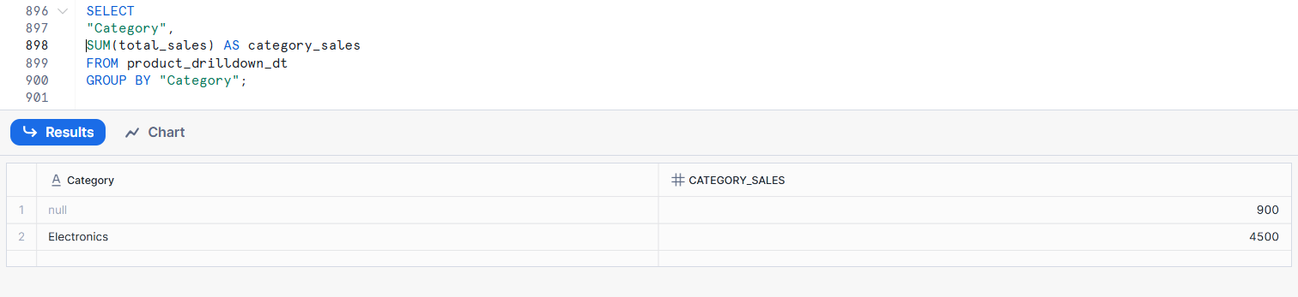
Product level
SELECT
"Category",
"Product",
SUM(total_sales) AS product_sales
FROM product_drilldown_dt
WHERE "Category" = 'Electronics'
GROUP BY "Category", "Product";
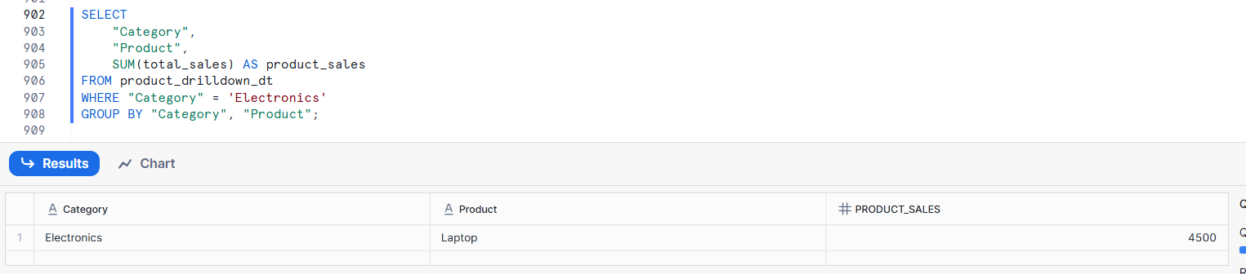
SKU level
SELECT
"Category",
"Product",
"SKU",
total_sales
FROM product_drilldown_dt
WHERE "Category" = 'Electronics'
AND "Product" = 'Laptop';
